MULTPLE REGRESSION-I
Regression analysis examines the relation between a single dependent variable Y and one or more independent variables X₁, …,X_{p.}

SIMPLE LINEAR REGRESSION MODELS

First Order Model with One Predictor Variable

$Y_{i}=β_{0}+β_{1}X_{i1}+ε_{i}$, i=1,2,…,n

- β₀ is the intercept of the line, and β₁ is the slope of the line. One unite increase in X gives β₁ unites increase in Y.

- ε_{i} is called a statistical random error for the i^{th} observation Y_{i}. It accounts for the fact that the statistical model does not give an exact fit to the data.

- ε_{i} cannot be observed. We assume:
  - E(ε_{i})=0
  - Var(ε_{i})=σ² for all i=1,…,n
  - Cov(ε_{i}, ε_{j})=0 for all i≠j

- Response/Regression function and an example:
$$\begin{aligned}E\left\{Y_{i}\right\}=β_{0}+β_{1}X_{i1} \\ E\left\{Y_{i}\right\}=9\text{.}5+2\text{.}1X_{i1}\end{aligned}$$
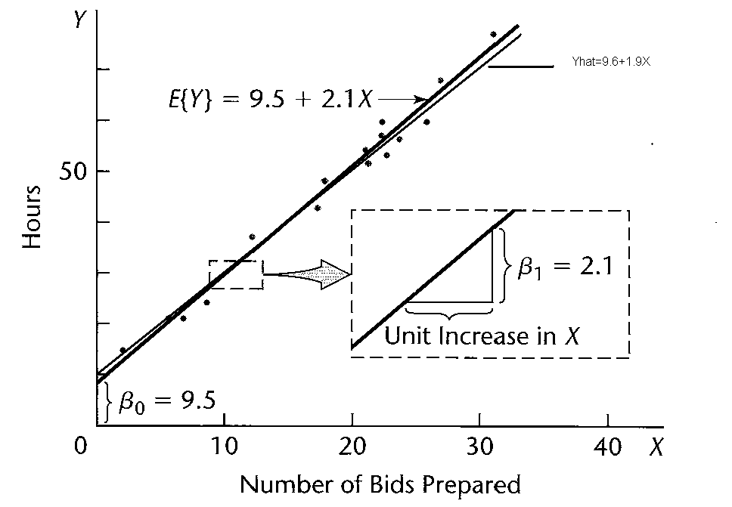

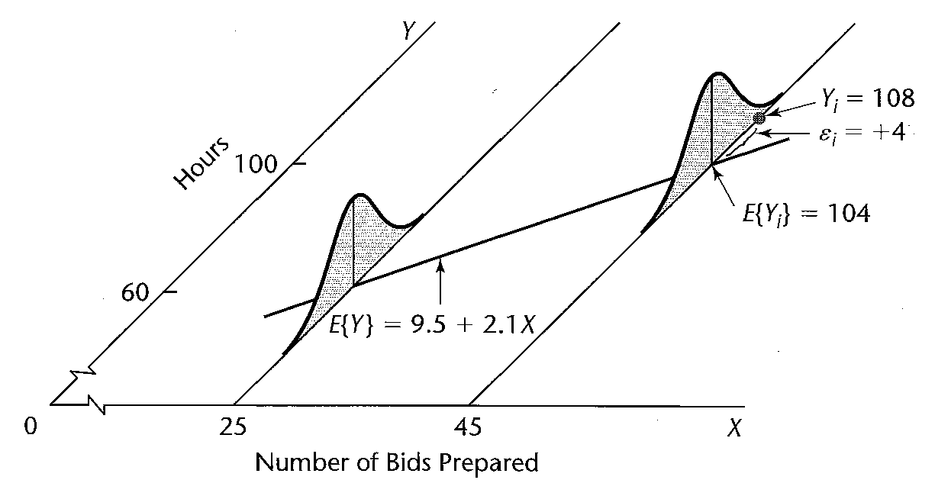

The response Y_{i}, given the level of X in the i^{th} trial X_{i}, comes from a probability distribution whose mean is 9.5+2.1 X_{i}. Therefore, Response/Regression function relates the means of the probability distributions of Y (for given X ) to the level of X.

- β₀, β₁, and ε are unknown parameters and have to be estimated from data. We use b₀, b₁, and e for the estimates of β₀, β₁, and ε.
- Fitted Values and an Example:

$$\begin{aligned}{\hat{Y}}_{i}=b_{0}+b_{1}X_{i1}\text{ is called fitted values } \\ {\hat{Y}}_{i}=9\text{.}6+1\text{.}9X_{i1}\end{aligned}$$
- Residual and an Example:

$$\begin{aligned}e_{i}=Y_{i}−{\hat{Y}}_{i}\text{ is called the residual value } \\ e_{i}=\text{108}−(9\text{.}6+1\text{.}9∗\text{45})=\text{12}\text{.}9 \\ ε_{i}=\text{108}−\text{104}=4\end{aligned}$$
- The residuals are observable, and can be used to check assumptions on the statistical random errors ε_{i}.
- Points above the line have positive residuals, and points below the line have negative residuals
- A line that fits the data well has small residuals.
- We want the residuals to be small in magnitude, because large negative residuals are as bad as large positive residuals. Therefore, we cannot simply require $\sum{e_{i}}=0\text{.}$
- In fact, $\sum{e_{i}}=0\text{.}$ (derivation on board).
- Two immediate solutions:
  - Require $\sum{|e_{i}|}$ to be small
  - Require $\sum{e_{i}^{2}}$ to be small
- We consider the second option because working with squares is mathematically easier than working with absolute values (for example, it is easier to take derivatives).

- Find the pair (b₀, b₁) that minimizes $\sum{e_{i}^{2}}$(least square estimates)
- We call SSE=$\sum{e_{i}^{2}}$the Residual Sum of Squares
- We want to find the pair (b₀, b₁) that minimizes
SSE=$\sum{e_{i}^{2}}$=$\sum{(Y_{i}−b_{0}−b_{1}X_{i})^{2}}$
- We set the partial derivatives of SSE with respect to b₀, b₁ equal to zero:
$$\begin{aligned}\text{Normal}\text{ equation }(1)\text{: }\frac{∂\text{SSE}}{β_{0}}=\sum{(−1)(2)(Y_{i}−}b_{0}−b_{1}X_{i})=0 \\ ⇒\sum{(Y_{i}−}b_{0}−b_{1}X_{i})=0 \\ \\ \text{Normal}\text{ equation }(2):\frac{∂\text{SSE}}{β_{1}}=\sum{(−X_{i})(2)(Y_{i}−}b_{0}−b_{1}X_{i})=0 \\ ⇒\sum{X_{i}(Y_{i}−}b_{0}−b_{1}X_{i})=0\end{aligned}$$
Then the solution is (derivation on board);
$$\begin{aligned}b_{0}=\hat{Y}−b_{1}X \\ b_{1}=\frac{\sum{(X_{i}−\bar{X})(Y_{i}−\bar{Y})}}{\sum{(X_{i}−\bar{X})^{2}}}\end{aligned}$$
- Properties of the residuals
- $\sum{e_{i}}=0\text{.}$ since the regression line goes through the point $(\bar{X},\bar{Y})$.
- $\sum{X_{i}e_{i}}=0\text{ and }\sum{{\hat{Y}}_{i}e_{i}}=0⇒$The residuals are uncorrelated with the independent variables X_{i} and with the fitted values ${\hat{Y}}_{i}$. (prove it on board)
Why $\sum{e_{i}}=0\text{.}$, $\sum{X_{i}e_{i}}=0\text{ and }\sum{{\hat{Y}}_{i}e_{i}}=0?$
In fact, from normal equation (1) and (2), we can immediately tell $\sum{e_{i}}=0$and $\sum{X_{i}e_{i}}=0$. Since $\sum{{\hat{Y}}_{i}e_{i}}=\sum{(b_{0}+b_{1}X_{i})e_{i}}=b_{0}\sum{e_{i}}+b_{1}\sum{X_{i}e_{i}}$, we can easily know that $\sum{{\hat{Y}}_{i}e_{i}}=0?$

- Least square estimates are uniquely defined as long as the values of the independent variable are not all identical. In that case the numerator $\sum{(X_{i}−\bar{X})^{2}}=0$ (draw figure).
- Point Estimation of Error Terms Variance σ²
- $\begin{aligned}s^{2}=\frac{\sum{{\left(Y_{i}−\bar{Y}\right)}^{2}}}{n−1} \\ E\left\{s^{2}\right\}=σ^{2}\end{aligned}$Single Population: Unbiased sample variance estimator of the population variance
$\begin{aligned}Y_{i}=μ+ε_{i},i=1,…,n \\ σ^{2}\left\{ε_{i}\right\}=σ^{2},σ\left\{ε_{i},ε_{j}\right\}=0\end{aligned}$
➔

- Regression model:Unbiased sample variance estimator of the population variance
$\begin{aligned}Y_{i}=β_{0}+β_{1}X_{i}+ε_{i},i=1,…,n \\ E\left\{ε_{i}\right\}=0,σ^{2}\left\{ε_{i}\right\}=σ^{2},σ\left\{ε_{i},ε_{j}\right\}=0\end{aligned}$

➔ $\begin{aligned}\text{MSE}=\frac{\text{SSE}}{n−2} \\ \begin{matrix}E\left\{\text{MSE}\right\}=σ^{2} & \end{matrix}\end{aligned}$

- $\begin{aligned}b_{1}=\frac{{\text{SS}}_{\text{XY}}}{{\text{SS}}_{\text{XX}}} \\ E\left\{b_{1}\right\}=β_{1} \\ σ^{2}\left\{b_{1}\right\}=\frac{σ^{2}}{{\text{SS}}_{\text{XX}}} \\ s^{2}\left\{b_{1}\right\}=\frac{\text{MSE}}{{\text{SS}}_{\text{XX}}}\end{aligned}$Inference in Regression Analysis:
Estimator of β₁
Mean of b₁
Variance of b₁
Estimated variance

$\begin{aligned}t^{}=\frac{b_{1}−β_{1}}{s\left\{b_{1}\right\}}\text{\sim }t\left(n−2\right) \\ 1−α\text{ CI:} \\ b_{1}±t\left(1−α/2;n−2\right)s\left\{b_{1}\right\} \\ s^{2}\left\{b_{1}\right\}=\frac{\text{MSE}}{{\text{SS}}_{\text{XX}}}\end{aligned}$

t-Score and 1-α CI of β1

- $\begin{aligned}E\left\{Y_{h}\right\}=β_{0}+β_{1}X_{h} \\ {\hat{Y}}_{h}=b_{0}+b_{1}X_{h} \\ E\left\{{\hat{Y}}_{h}\right\}=E\left\{Y_{h}\right\} \\ σ^{2}\left\{{\hat{Y}}_{h}\right\}=σ^{2}\left[\frac{1}{n}+\frac{{\left(X_{h}−\bar{X}\right)}^{2}}{{\text{SS}}_{\text{XX}}}\right] \\ s^{2}\left\{{\hat{Y}}_{h}\right\}=\text{MSE}\left[\frac{1}{n}+\frac{{\left(X_{h}−\bar{X}\right)}^{2}}{{\text{SS}}_{\text{XX}}}\right]\end{aligned}$Estimating the Mean Value at X_{h}:
Estimator
Mean
Variance
Estimated variance

- Analysis of Variance Approach to Regression Analysis
$\begin{aligned}{\text{SS}}_{\text{TOT}}=\text{SSR}+\text{SSE} \\ Y_{i}−\bar{Y}={\hat{Y}}_{i}−\bar{Y}\text{}+\text{}Y_{i}−{\hat{Y}}_{i} \\ \sum{{\left(Y_{i}−\bar{Y}\right)}^{2}}=\sum{{\left({\hat{Y}}_{i}−\bar{Y}\text{}+\text{}Y_{i}−{\hat{Y}}_{i}\right)}^{2}} \\ \sum{{\left({\hat{Y}}_{i}−\bar{Y}\right)}^{2}}+\sum{{\left(Y_{i}−\hat{Y}\right)}^{2}}\end{aligned}$

$\begin{aligned}F^{}=\frac{\text{MSR}}{\text{MSE}} \\ F^{}=\frac{\text{MSR}}{\text{MSE}}\text{\sim }F\left(1,n−2\right) \\ \text{Tail Probability:} \\ P\left\{F^{}>F\left(1−α;1,n−2\right)\right\}=α\end{aligned}$
- Test Statistic
- F Distribution
- Numerator
Degrees of Freedom df_{R}=1
- Denominator
Degrees of Freedom df_{R}=n-1

$\begin{aligned}H_{0}:β_{1}=0 \\ H_{1}:β_{1}≠0 \\ \text{For }α\text{ level of significance} \\ \text{If }F^{}≤F\left(1−α;1,n−2\right)⇒H_{0} \\ \text{If }F^{}>F\left(1−α;1,n−2\right)⇒H_{1}\end{aligned}$
- Hypothesis:

- Decision Rule:

Fitting a regression in SAS
data Toluca;
infile 'C:\stat231B06\ch01ta01.txt';
input lotsize workhrs;
proc reg; /*least square estimation of regression coefficient*/
model workhrs=lotsize;
output out=results p=yhat r=residual;/*yhat denotes for fitted values and residual denotes for residual values*/
run;

proc print data=results;
var yhat residual; /*print the fitted values and residual vales*/
run;

SAS Output

The REG Procedure
Model: MODEL1
Dependent Variable: workhrs

Number of Observations Read 25
Number of Observations Used 25

Analysis of Variance

Sum of Mean
Source DF Squares Square F Value Pr > F

Model 1 252378 252378 105.88 <.0001
Error 23 54825 2383.71562
Corrected Total 24 307203

Root MSE 48.82331 R-Square 0.8215
Dependent Mean 312.28000 Adj R-Sq 0.8138
Coeff Var 15.63447

Parameter Estimates
Parameter Standard
Variable DF Estimate Error t Value Pr > |t|
Intercept 1 62.36586 26.17743 2.38 0.0259
lotsize 1 3.57020 0.34697 10.29 <.0001

Obs yhat residual

1 347.982 51.018
2 169.472 -48.472
3 240.876 -19.876
4 383.684 -7.684
5 312.280 48.720
6 276.578 -52.578
7 490.790 55.210
8 347.982 4.018
9 419.386 -66.386
10 240.876 -83.876
11 205.174 -45.174
12 312.280 -60.280
13 383.684 5.316
14 133.770 -20.770
15 455.088 -20.088
16 419.386 0.614
17 169.472 42.528
18 240.876 27.124
19 383.684 -6.684
20 455.088 -34.088
21 169.472 103.528
22 383.684 84.316
23 205.174 38.826
24 347.982 -5.982
25 312.280 10.720

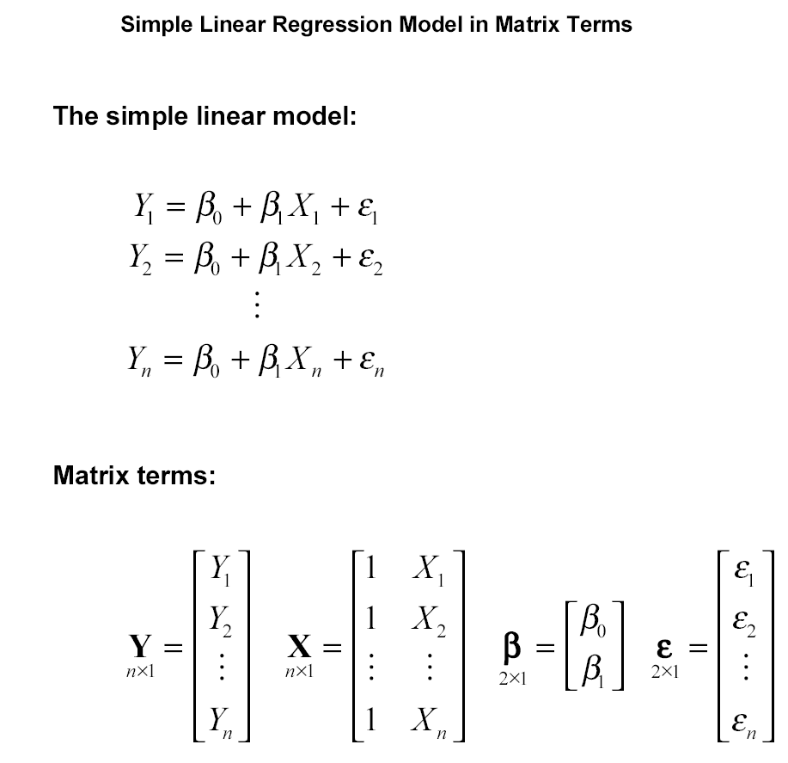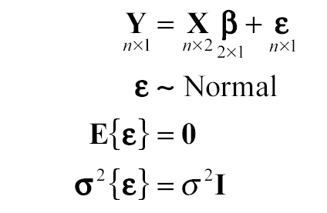
Extension to multiple regression model
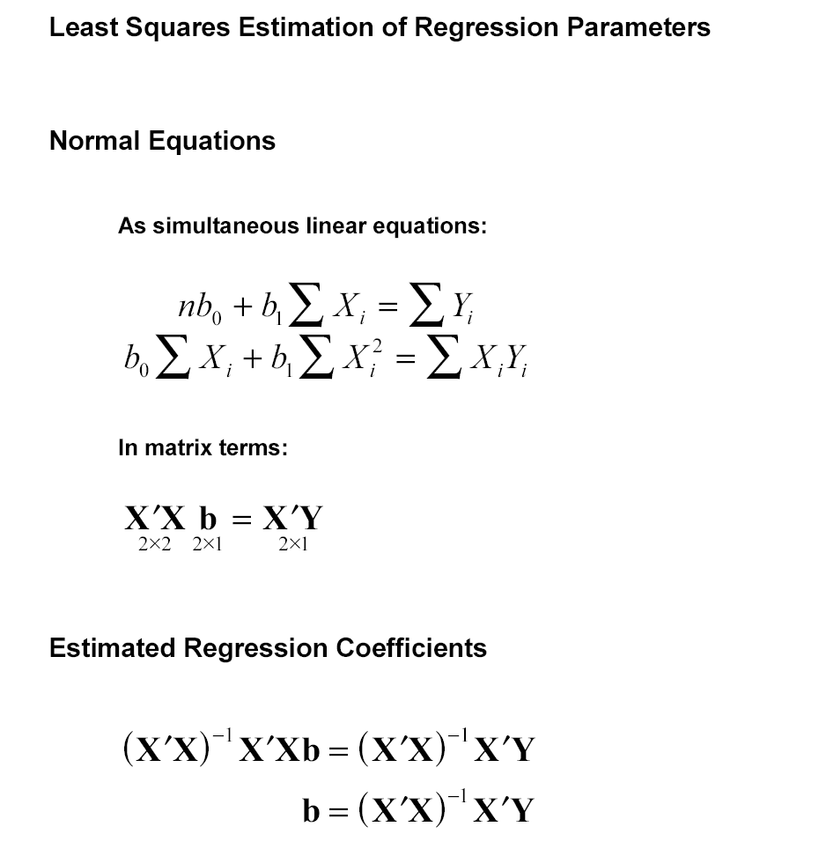

Extension to multiple regression model:

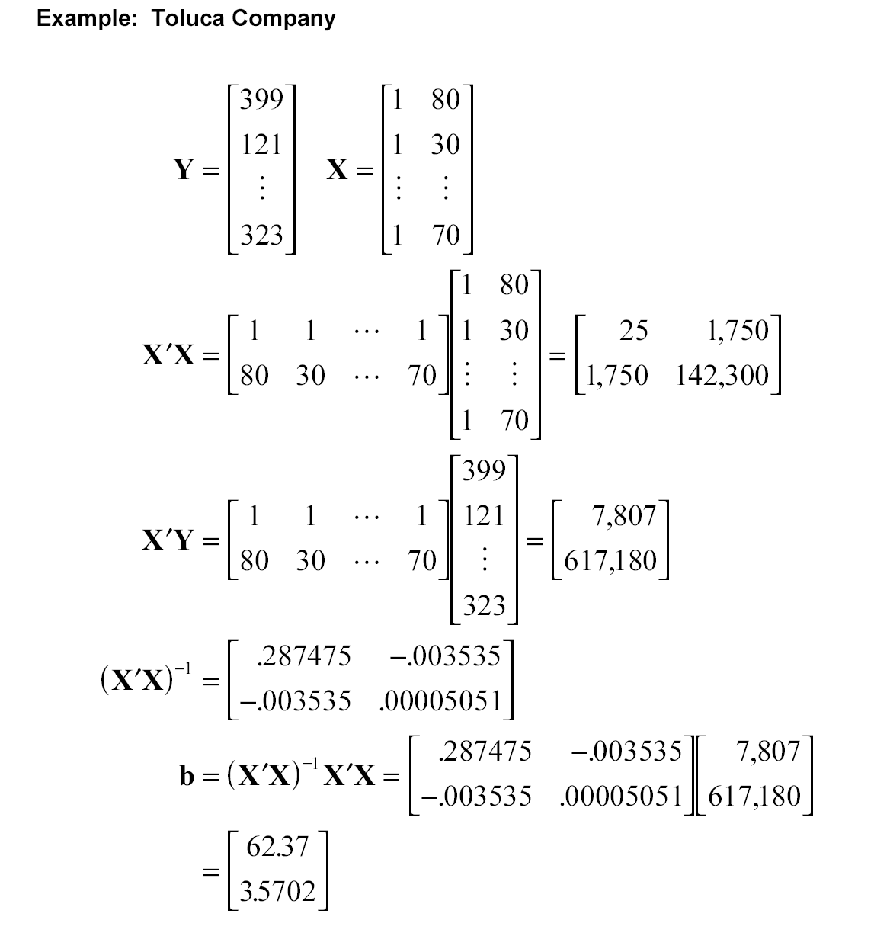

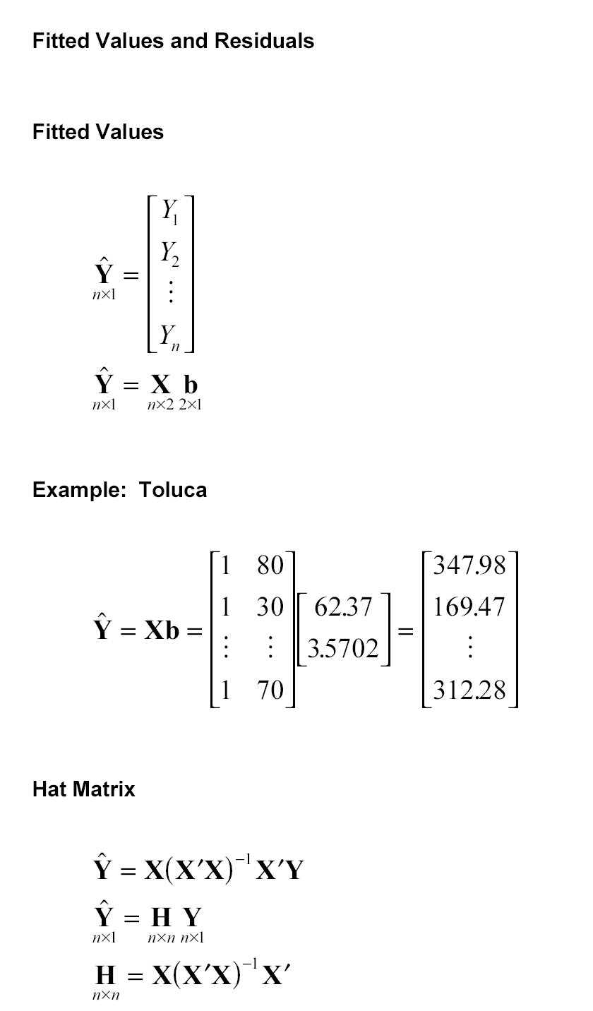
Extension to multiple regression model

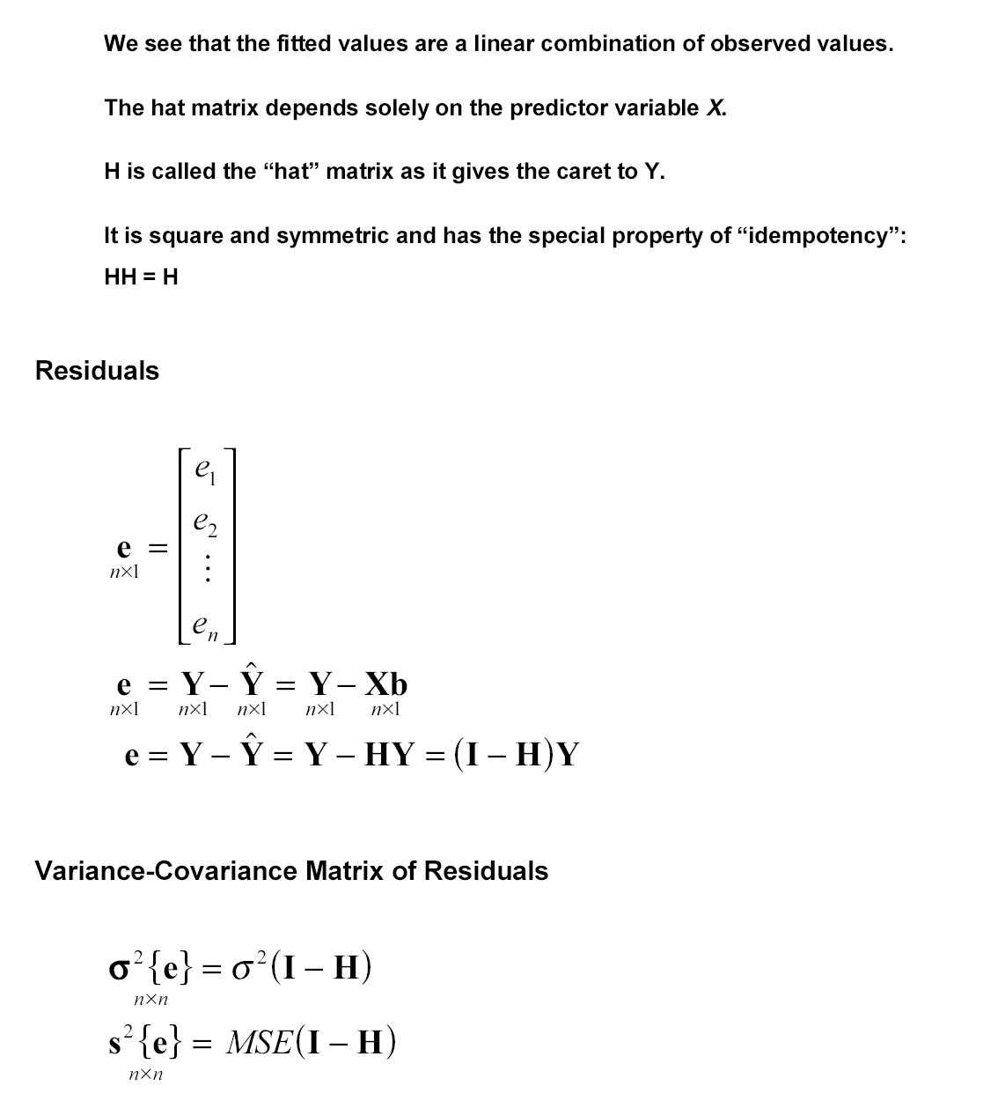

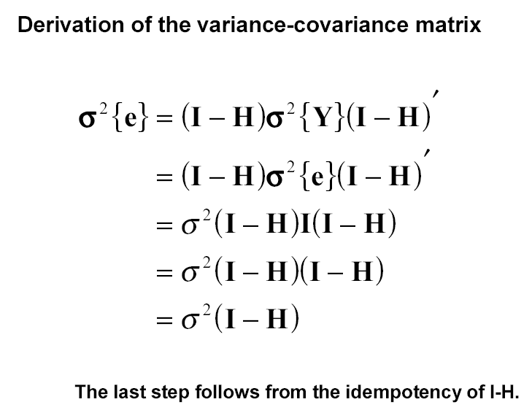
Extension to multiple regression model
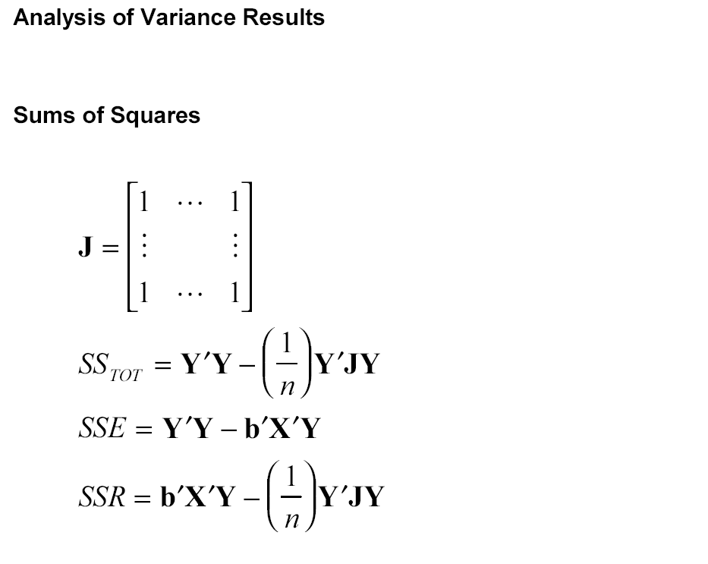
Extension to multiple regression model

Degrees of freedom: the number of independent components that are needed to calculate the respective sum of squares.
- SS_{TOT} is the sum of n squared components. However, since $\sum{(y_{i}−\bar{y})}=0$, only n-1 components are needed for its calculation. The remaining one can always be calculated from $y_{n}−\bar{y}=−\sum_{i=1}^{n−1}{(y_{i}−\bar{y})}$. Hence, SS_{TOT} has n-1 degrees of freedom.
- SSE=$\sum{e_{i}^{2}}$ is the sum of n squared components. However, there are p restrictions among the residuals, coming from the p normal equations $\underset{p×1}{X^{'}Y}−\underset{p×p}{X^{'}X}\underset{p×1}{b}=X'(Y−\text{Xb})=X'e=0$. Hence SSE has n-p degrees of freedom.
- SSR=$\sum{({\hat{y}}_{i}−\bar{y})^{2}}$is the sum of p squared components since all fitted values ${\hat{Y}}_{i}$are calculated from the same estimated regression line. One degree of freedom is lost because of one restriction $\sum{({\hat{y}}_{i}−\bar{y})}=\sum{({\hat{y}}_{i}−y_{i}+y_{i}−\bar{y})}=\sum{({\hat{y}}_{i}−y_{i})}+\sum{(y_{i}−\bar{y})}=0$. Hence SSR has p-1 degrees of freedom.

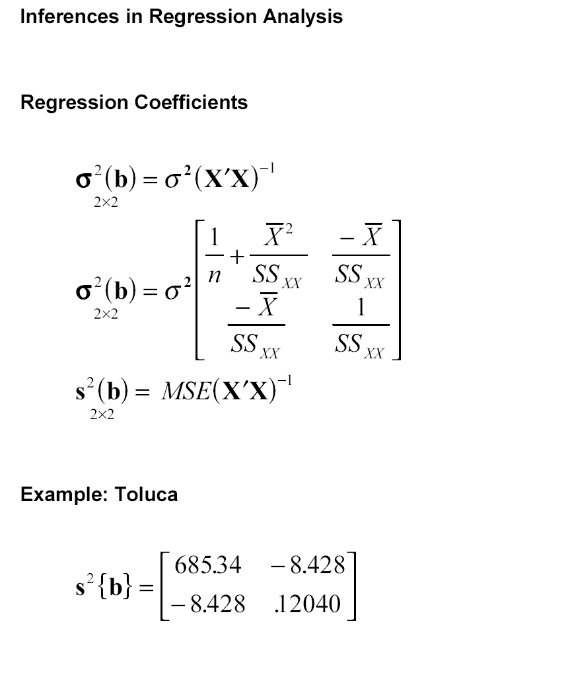
Extension to multiple regression model

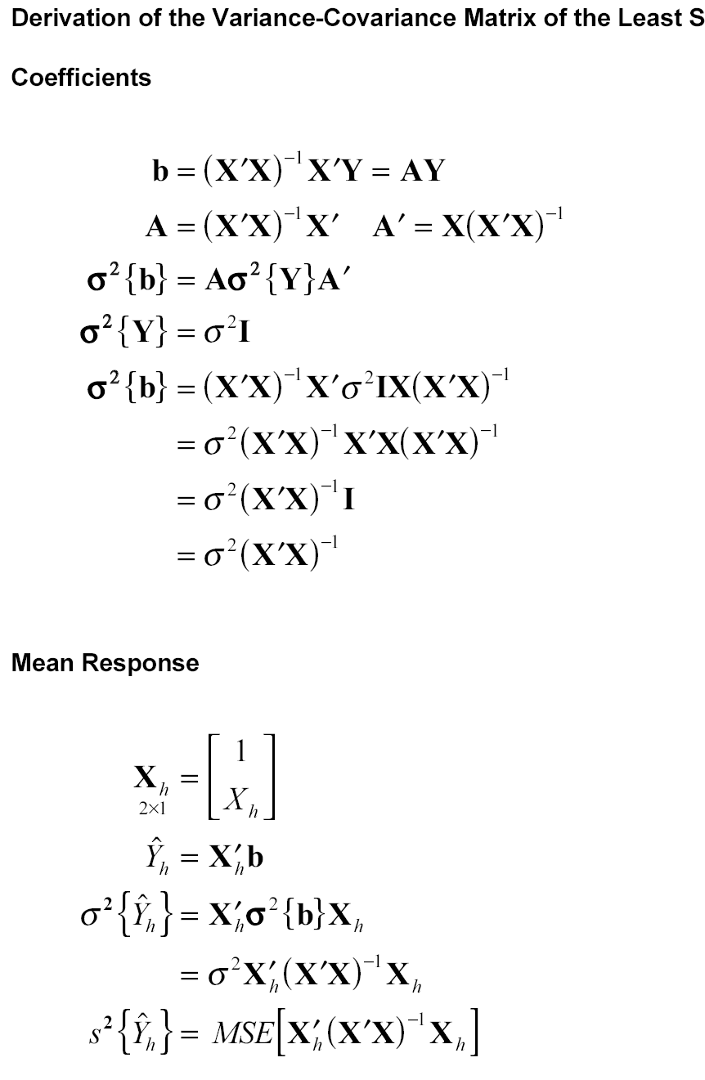
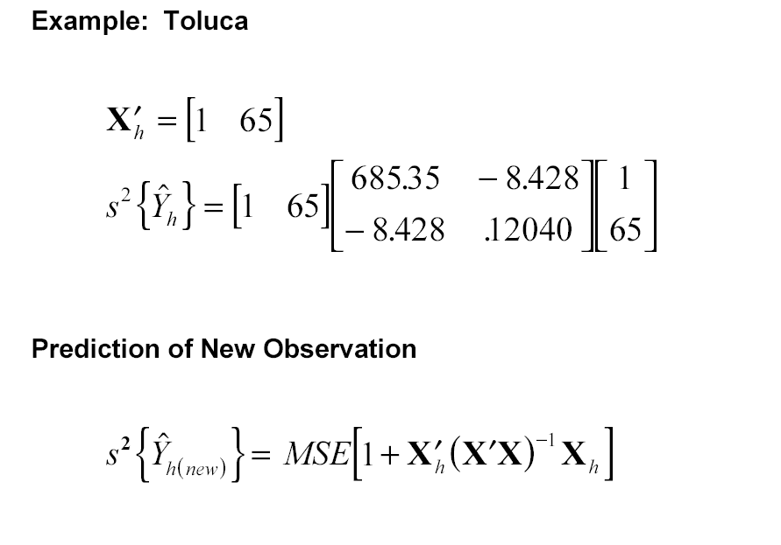

Extension to multiple regression model

