Automatic Model Selection Methods
- Model Selection Criteria
- Score Chi-square criteria
(1) AIC_{p}=-2log_{e}L(b)+2p
(2) SBC_{p}=-2log_{e}L(b)+plog_{e}(n)
Where log_{e}L(b)$=\sum_{i=1}^{n}{Y_{i}(X_{i}^{'}b)−}\sum_{i=1}^{n}{{\text{log}}_{e}[1+\text{exp}(X_{i}^{'}b)]}$
Promising models will yield relatively small values for these criteria.
(4) A third criterion that is frequently provided by SAS is -2log_{e}L(b).
For this criterion, we also seek models giving small values. A drawback of this criterion is that it will never increase as terms are added to the model, because there is no penalty for adding predictors. This is analogous to the use of SSE_{p} or $R_{p}^{2}$in multiple linear regression.
- Best Subsets Procedures
“Best” subsets procedures were discussed in Section 9.4 in ALSM in the context of multiple linear regression. Recall that these procedures identify a group of subset models that give the best values of a specified criterion. We now illustrate the use of the best subset procedure based on Score chi-square. SAS doesn’t provide automatic best subsets procedures based on AIC and SBC criteria.
Example:  $Y=\left\{\begin{matrix}\text{1 disease present} \\ \text{0 disease absent }\end{matrix}\right.$ $\begin{aligned}X_{1}−\text{Age} \\ \left.\begin{matrix}X_{2}=\left\{\begin{matrix}\text{1 Middle Class} \\ \text{0 others}\end{matrix}\right. \\ X_{3}=\left\{\begin{matrix}1\text{ Lower Class} \\ 0\text{ others}\end{matrix}\right.\end{matrix}\right\}\text{socioeconomic status}\end{aligned}$  $$X_{4}=\left\{\begin{matrix}\text{1 city sector 2} \\ \text{0 city sector 1 }\end{matrix}\right.$$  Study purpose: assess the strength of the association between each of the predictor variables and the probability of a person having contracted the disease
  Case  i  1  2  3  4  5  6  .  98 | Age  X_{i1}  33  35  6  60  18  26  .  35 | Socioeconomic Status  X_{i2} X_{i3}  0 0  0 0  0 0  0 0  0 1  0 1  .  0 1 | City Sector  X_{i4}  0  0  0  0  0  0  .  0 | Disease Status  Y_{i}  0  0  0  0  1  0  .  0 | Fitted Value  $${\hat{π}}_{i}$$  .209  .219  .106  .371  .111  .136  .  .171
SAS CODE 1 (Score Chi-square):  data ch14ta03;  infile 'c:\stat231B06\ch14ta03.txt' DELIMITER='09'x;  input case x1 x2 x3 x4 y;  proc logistic data=ch14ta03;  model y (event='1')=x1 x2 x3 x4/selection=score;  run; | SAS OUTPUT1:  Regression Models Selected by Score Criterion  Number of Score  Variables Chi-Square Variables Included in Model  1 14.7805 x4  1 7.5802 x1  1 3.9087 x3  1 1.4797 x2  2 19.5250 x1 x4  2 15.7058 x3 x4  2 15.3663 x2 x4  2 10.0177 x1 x3  2 9.2368 x1 x2  2 4.0670 x2 x3  3 20.2719 x1 x2 x4  3 20.0188 x1 x3 x4  3 15.8641 x2 x3 x4  3 10.4575 x1 x2 x3  4 20.4067 x1 x2 x3 x4

- Forward, Backward Stepwise Model Selection
When the number of predictors is large (i.e., 40 or more) the use of all-possible-regression procedures for model selection may not be feasible. In Such cases, forward, backward or stepwise selection procedures are generally employed. The decision rule for adding or deleting a predictor variable in SAS is based on wald chisquare statistics.

SAS CODE 2 (Forward selection):  data ch14ta03;  infile 'c:\stat231B06\ch14ta03.txt' DELIMITER='09'x;  input case x1 x2 x3 x4 y;  proc logistic data=ch14ta03;  model y (event='1')=x1 x2 x3 x4/selection=forward;  run;  If you want to use backward selection procedure, you can specify selection=backward; If you want to use stepwise selection procedure, you can specify selection=stepwise. | SAS OUTPUT2:  Summary of Forward Selection  Effect Number Score  Step Entered DF In Chi-Square Pr > ChiSq  1 x4 1 1 14.7805 0.0001  2 x1 1 2 5.2385 0.0221  Analysis of Maximum Likelihood Estimates  Standard Wald  Parameter DF Estimate Error Chi-Square Pr > ChiSq  Intercept 1 -2.3350 0.5111 20.8713 <.0001  x1 1 0.0293 0.0132 4.9455 0.0262  x4 1 1.6734 0.4873 11.7906 0.0006  Odds Ratio Estimates  Point 95% Wald  Effect Estimate Confidence Limits  x1 1.030 1.003 1.057  x4 5.330 2.051 13.853

Test for Goodness of Fit
- Pearson Chi-Square Goodness of Fit Test:
It can detect major departures from a logistic response function, but is not sensitive to small departures from a logistic response function
Hypothesis: H₀: E{Y}=[1+exp(-Xβ)]⁻¹
H_{a}: E{Y}≠[1+exp(-Xβ)]⁻¹
Test Statistic: $Χ^{2}=\sum_{j=1}^{c}{\sum_{k=0}^{1}{\frac{(O_{\text{jk}}−E_{\text{jk}})^{2}}{E_{\text{jk}}}}}$~$χ^{2}(c−p)$
P is the number of predictor variables+1;
c is the distinct combinations of the predictor variables;
O_{j0}= the observed number of 0 in the jth class;
O_{j1}= the observed number of 1 in the jth class;
E_{j0}= the expected number of 0 in the jth class when H₀ is true;
E_{j1}= the expected number of 1 in the jth class when H₀ is true
Decision Rule:
$\begin{aligned}{\text{If Χ}}^{2}≤χ^{2}(1−\text{α;c}−p){\text{, conclude H}}_{0} \\ {\text{If Χ}}^{2}>χ^{2}(1−\text{α;c}−p){\text{, conclude H}}_{a}\end{aligned}$
- Deviance Goodness of Fit Test:
The deviance goodness of fit test for logistic regression models is completely analogous to the F test for lack of fit for simple and multiple linear regression models.
Hypothesis: H₀: E{Y}=[1+exp(-Xβ)]⁻¹
H_{a}: E{Y}≠[1+exp(-Xβ)]⁻¹
Likelihood Ratio Statistic:
Full Model: E{Y_{ij}}=π_{j}, j=1,2,...c
Reduced Model: Y_{ij}=[1+exp(-X_{j}`β)]⁻¹
c is the distinct combinations of the predictor variables;
$G^{2}=−{\text{2log}}_{e}\left[\frac{L(R)}{L(F)}\right]=−2\sum_{j=1}^{c}{[Y_{\text{.}j}{\text{log}}_{e}(\frac{{\hat{π}}_{j}}{p_{j}})+(n_{j}−Y_{\text{.}j}){\text{log}}_{e}(\frac{1−{\hat{π}}_{j}}{1−p_{j}})]=\text{DEV}(X_{0},X_{1},\text{.}\text{.}\text{.}X_{p−1})}$
Decision Rule:
$\begin{aligned}{\text{If Χ}}^{2}≤χ^{2}(1−\text{α;c}−p){\text{, conclude H}}_{0} \\ {\text{If Χ}}^{2}>χ^{2}(1−\text{α;c}−p){\text{, conclude H}}_{a}\end{aligned}$
Level
j  1  2  3  4  5 | Price Reduction  X_{j}  5  10  15  20  30 | Number of Households  n_{j}  200  200  200  200  200 | Number of Coupons Redeemed Y_{..j}  30  55  70  100  137 | Proportion of Coupons Redeemed p_{j}  .150  .275  .350  .500  .685 | Mondel-Based Estimate ${\hat{π}}_{j}$  .1736  .2543  .3562  .4731  .7028

SAS CODE:  data ch14ta02;  infile 'c:\stat231B06\ch14ta02.txt';  input x n y pro;  run;  proc logistic data=ch14ta02;  /*The option scale=none is specified /*to produce the deviance and */  /*Pearson goodness-of-fit analysis*/  model y/n=x /scale=none;  run;  Note: To request the Pearson Chi-Square Goodness of Fit test, we use the aggregate and scale options on the model statement, i.e. “ model y/n=x /aggregate=(x)scale=pearson;”. | SAS OUTPUT:  Deviance and Pearson Goodness-of-Fit Statistics  Criterion Value DF Value/DF Pr > ChiSq  Deviance 2.1668 3 0.7223 0.5385  Pearson 2.1486 3 0.7162 0.5421  Number of events/trials observations: 5  Since p-value=0.5385 for deviance goodness of fit test and p-value=0.5421 for pearson chi-square goodness of fit test, we conclude H₀ that the logistic regression response function is appropriate.

- Hosmer-Lemeshow Goodness of Fit Test
This test is designed for either unreplicated data sets or data sets with few replicates through grouping of cases based on the values of the estimated probabilities. The procedure consists of grouping the data into classes with similar fitted values ${\hat{π}}_{i}$, with approximately the same number of cases in each class. Once the group are formed, the Pearson chi-square test statistic is used

SAS CODE (the disease outbreak example)  data ch14ta03;  infile 'c:\stat231B06\ch14ta03.txt' DELIMITER='09'x;  input case x1 x2 x3 x4 y;  run;  proc logistic data=ch14ta03;  model y (event='1')=x1 x2 x3 x4/lackfit;  run;  We use the lackfit option on the proc logistic model statement. Partial results are found in the SAS OUTPUT on the right. | SAS OUTPUT:  Partition for the Hosmer and Lemeshow Test  y = 1 y = 0  Group Total Observed Expected Observed Expected  1 10 0 0.79 10 9.21  2 10 1 1.02 9 8.98  3 11 2 1.51 9 9.49  4 10 1 1.78 9 8.22  5 10 3 2.34 7 7.66  6 10 4 3.09 6 6.91  7 10 7 3.91 3 6.09  8 11 3 5.51 8 5.49  9 10 5 6.32 5 3.68  10 6 5 4.75 1 1.25  Hosmer and Lemeshow Goodness-of-Fit Test  Chi-Square DF Pr > ChiSq  9.1871 8 0.3268  Note that X²=9.189(p-value=0.327) and the text reports X²=1.98(p-value=0.58). Although the difference in magnitudes of the test statistic is large, the p-values lead to the same conclusion. The discrepancy is due to the test statistics being based on different contingency table, i.e., 2 by 5 versus 2 by 10. The use of 20 cells (2×10) decreases the expected frequencies per cell relative to the use of 10 cells (2×5). However, Hosmer and Lemeshow take a liberal approach to expected values and argue that their method is an accurate assessment of goodness of fit.

Logistic Regression Diagnostics
Residual Analysis and the identification of influential cases.
- Logistic Regression Residuals
  - Pearson Residuals
$$r_{P_{i}}=\frac{Y_{i}−{\hat{π}}_{i}}{\sqrt{{\hat{π}}_{i}(1−{\hat{π}}_{i})}}$$
Pearson Chi-Square Goodness of Fit statistic
$$Χ^{2}=\sum_{i=1}^{n}{\sum_{j=0}^{1}{\frac{(O_{\text{ij}}−E_{\text{ij}})^{2}}{E_{\text{ij}}}}}=\sum_{i=1}^{n}{\frac{(Y_{i}−{\hat{π}}_{i})^{2}}{{\hat{π}}_{i}(1−{\hat{π}}_{i})}}=\sum_{i=1}^{n}{r_{P_{i}}^{2}}$$
  - Studentized Pearson Residuals
${\begin{aligned}r_{{\text{SP}}_{i}}=\frac{r_{P_{i}}}{\sqrt{1−h_{\text{ii}}}},\text{ where } \\ h_{\text{ii}}\text{ is the ith diagonal element of the matrix H}={\hat{W}}^{\text{1/2}}X(X'\hat{W}X)^{−1}X'{\hat{W}}^{1/2}, \\ \hat{W}\text{ is the n}×\text{n diagonal matrix with elements \{}\hat{π}\end{aligned}}_{i}(1−{\hat{π}}_{i})$,
  - Deviance Residuals
$$\begin{aligned}{\text{dev}}_{i}=\text{sign}(Y_{i}−{\hat{π}}_{i})\sqrt{\text{-2}[Y_{i}{\text{log}}_{e}({\hat{π}}_{i})+(1−Y_{i}){\text{log}}_{e}(1−{\hat{π}}_{i})} \\ \text{where }\text{sign}(Y_{i}−{\hat{π}}_{i})\text{ is positive if }Y_{i}≥{\hat{π}}_{i}\text{ and negative when }Y_{i}<{\hat{π}}_{i} \\ \sum_{i=1}^{n}{({\text{dev}}_{i})^{2}}=\text{DEV}(X_{0},X_{1},\text{.}\text{.}\text{.},X_{p−1})\end{aligned}$$
- Detection of Influential Observations
We consider the influence of individual binary cases on three aspects of the analysis (1) The Pearson Chi-Square statistic (2) The deviance statistic (3) the fitted linear predictor, ${\hat{π}}_{i}^{'}$
Influence on Pearson Chi-Square and the Deviance Statistics.
ith delta chi-square statistic:${ΔX}_{i}^{2}=X^{2}−X_{(i)}^{2}≈r_{{\text{SP}}_{i}}^{2}$
$$X_{(i)}^{2}\text{ denotes Pearson Chi-Square Statistic when case i is deleted}$$
ith delta deviance statistic: $Δ{\text{dev}}_{i}=\text{DEV}−{\text{DEV}}_{(i)}≈h_{\text{ii}}r_{{\text{SP}}_{i}}^{2}+{\text{dev}}_{i}^{2}$
${\text{DEV}}_{(i)}\text{ denotes Deviance Statistic when case i is deleted}$
As we can see, ${ΔX}_{i}^{2}\text{ and }Δ{\text{dev}}_{i}$ give the change in the Pearson chi-square and deviance statistics, respectively, when the ith case is deleted. They therefore provide measures of the influence of the ith case on these summary statistics.
The interpretation of the delta chi-square and delta deviance statistics is not as simple as those statistics that we used for regression diagnostic. This is because the distribution of the delta statistics is unknown except under certain restrictive assumptions. The judgment as to whether or not a case is outlying or overly influential is typically made on the basis of a subjective visual assessment of an appropriate graphic. Usually, the delta chi-square and delta deviance statistics are plotted against case number I, against ${{\hat{π}}_{i}\text{, or against \{}\hat{π}}_{i}^{'}$. Extreme values appear as spikes when plotted against case number, or as outliers in the upper corners of the plot when plotted against ${{\hat{π}}_{i}\text{, or against \{}\hat{π}}_{i}^{'}$
Influence on the Fitted Linear Predictor: Cook’s Distance.
The following one-step approximation is used to calculate Cook’s Distance:
$$D_{i}=\frac{r_{p_{i}}^{2}h_{\text{ii}}}{p(1−h_{\text{ii}})^{2}}$$

Extreme values appear as spikes when plotted against case number.
Note that influence on both the deviance (or Pearson chi-square) statistic and the linear predictor can be assessed simultaneously using a proportional influence or bubble plot of the delta deviance ( or delta chi-square) statistics, in which the area of the plot symbol is proportional to D_{i}.

The disease outbreak example.
SAS CODE:
/*In the output statement immediately following the model statement*/
/*we set yhat=p(estimated probability,${\hat{π}}_{i}$),chires=reschi(pearson residual,$r_{\text{pi}}$),*/
/*devres=resdev(deviance residual, dev_{i}),difchsq=difchisq(delta chi-square ${Δχ}_{i}^{2}$)*/
/*difdev=difdev(delta deviance, $Δ{\text{dev}}_{i}$),hatdiag=h(diagonal elements of the hat matrix*/
/*Here p,reschi,resdev,difchisq, difdev and h are SAS key words for the respective */
/*variables. We then output them into results1 so that the data for all variables will*/
/*be assessable in one file. We then use equation 14.81 (text page 592) to find rsp */
/*(studentized Pearson residual, rsp_{i}) and equation 14.87 (text page 600) to find */
/*cookd (COOK's Distance, D_{i}) [SAS OUTPUT1].*/

/*The INFLUENCE option [SAS OUTPUT 2] and the IPLOTS option are specified to display*/
/*the regression diagnostics and the index plots [SAS OUTPUT 3]*/

/*The values in SAS OUTPUT 1 can be used to generate various pltos as displayed*/
/*in the text [SAS OUTPUT 4]. For example, we can generate Figure 14.15 (c) and(d),*/
/*text page 600 by using proc gplot to plot (difchisq difdev) *yhat; we can generate */
/*Figure 14.16 (c) by using proc gplot with bubble difdevsqr*yhat=cookd;*/
/*we can generate Figure 14.16 (b)by using proc gplot with */
/*symbol1 color=black value=none interpol=join; plot cookd*case; */

data ch14ta03;
infile 'c:\stat231B06\ch14ta03.txt' DELIMITER='09'x;
input case x1 x2 x3 x4 y;
run;

ods html;
ods graphics on; /*ods graphics version of plots are produced*/
proc logistic data=ch14ta03;
model y (event='1')=x1 x2 x3 x4 /influence iplots ;
output out=results1 p=yhat reschi=chires resdev=devres difchisq=difchisq difdev=difdev h=hatdiag;
run;

data results2;
set results1;
rsp=chires/(sqrt(1-hatdiag));
cookd=((chires**2)*hatdiag)/(5*(1-hatdiag)**2);
difdevsqr=difdev**2;
proc print;
var yhat chires rsp hatdiag devres difchisq difdev cookd;
run;

proc gplot data=results2;
plot (difchisq difdev)*yhat;
run;

proc gplot data=results2;
bubble difdevsqr*yhat=cookd;
run;

proc gplot data=results2;
symbol1 color=black value=none interpol=join;
plot cookd*case;
run;

ods graphics off;
ods html close;

SAS OUTPUT 1:

The SAS System

Obs | yhat | chires | rsp | hatdiag | devres | difchisq | difdev | cookd
1 | 0.20898 | -0.51399 | -0.52425 | 0.03873 | -0.68473 | 0.27483 | 0.47951 | 0.002215
2 | 0.21898 | -0.52951 | -0.54054 | 0.04041 | -0.70308 | 0.29219 | 0.50612 | 0.002461
3 | 0.10581 | -0.34400 | -0.34985 | 0.03320 | -0.47295 | 0.12240 | 0.22774 | 0.000841
. | . | . | . | . | . | . | . | .
. | . | . | . | . | . | . | . | .
. | . | . | . | . | . | . | . | .
96 | 0.11378 | -0.35832 | -0.36297 | 0.02545 | -0.49152 | 0.13175 | 0.24494 | 0.000688
97 | 0.09190 | -0.31812 | -0.32202 | 0.02406 | -0.43910 | 0.10370 | 0.19530 | 0.000511
98 | 0.17126 | -0.45459 | -0.46289 | 0.03555 | -0.61294 | 0.21427 | 0.38332 | 0.001580
SAS OUTPUT 2:
Regression Diagnostics
Case  Number | Covariates |  |  |  | Pearson Residual | Deviance Residual | Hat Matrix Diagonal | Intercept DfBeta | x1 DfBeta | x2 DfBeta | x3 DfBeta | x4 DfBeta | Confidence Interval  Displacement C | Confidence Interval  Displacement  CBar | Delta Deviance | Delta Chi-Square
Case  Number | x1 | x2 | x3 | x4
1 | 33.0000 | 0 | 0 | 0 | -0.5140 | -0.6847 | 0.0387 | -0.0759 | -0.00487 | 0.0529 | 0.0636 | 0.0659 | 0.0111 | 0.0106 | 0.4795 | 0.2748
2 | 35.0000 | 0 | 0 | 0 | -0.5295 | -0.7031 | 0.0404 | -0.0756 | -0.0113 | 0.0546 | 0.0662 | 0.0689 | 0.0123 | 0.0118 | 0.5061 | 0.2922
3 | 6.0000 | 0 | 0 | 0 | -0.3440 | -0.4729 | 0.0332 | -0.0645 | 0.0374 | 0.0323 | 0.0356 | 0.0352 | 0.00420 | 0.00406 | 0.2277 | 0.1224
. |  |  |  |  |  |  |  |  |  | 0.0779 | 0.1059 | 0.1161 | 0.0637 | 0.0580 | 0.9852 | 0.6478
. |  |  |  |  |  |  |  |  |  | -0.0223 | 0.2675 | -0.1725 | 0.2127 | 0.2073 | 4.6070 | 8.2311
. |  |  |  |  |  |  |  |  |  | 0.00128 | -0.0426 | 0.0258 | 0.00474 | 0.00461 | 0.2982 | 0.1627
96 | 19.0000 | 0 | 1.0000 | 0 | -0.3583 | -0.4915 | 0.0255 | -0.0188 | 0.0131 | 0.00263 | -0.0344 | 0.0220 | 0.00344 | 0.00335 | 0.2449 | 0.1317
97 | 11.0000 | 0 | 1.0000 | 0 | -0.3181 | -0.4391 | 0.0241 | -0.0218 | 0.0208 | 0.00357 | -0.0268 | 0.0183 | 0.00256 | 0.00250 | 0.1953 | 0.1037
98 | 35.0000 | 0 | 1.0000 | 0 | -0.4546 | -0.6129 | 0.0356 | -0.00330 | -0.0184 | -0.00145 | -0.0557 | 0.0316 | 0.00790 | 0.00762 | 0.3833 | 0.2143

SAS OUTPUT3:
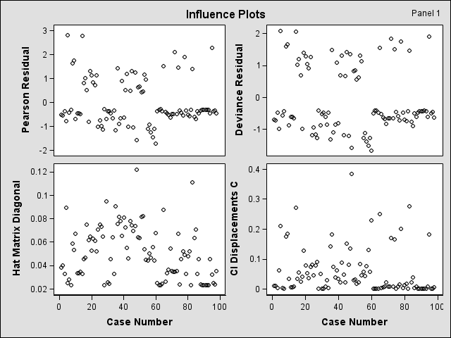
The leverage plot (on the lower left corner) identifies case 48 as being somewhat outlying in the X space- and therefore potentially influential

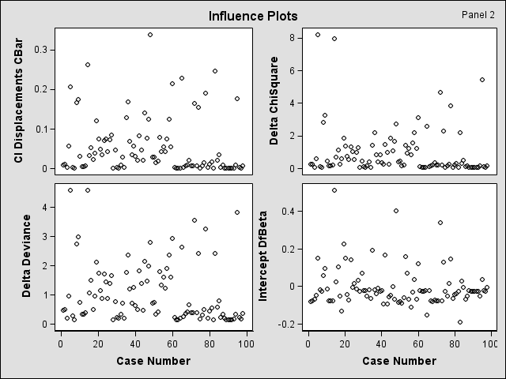
The index plots of the delta chi-square (on the upper right corner) and delta deviance statistics (on the lower left corner) have two spikes corresponding to cases 5 and 14.

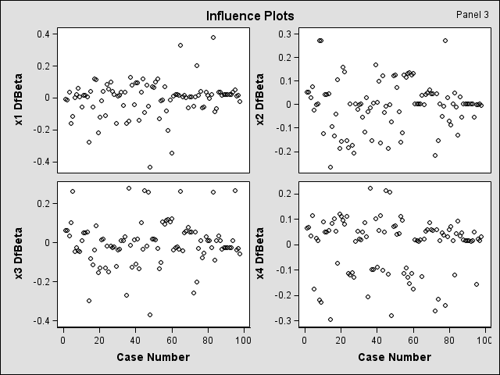
SAS OUTPUT 4:
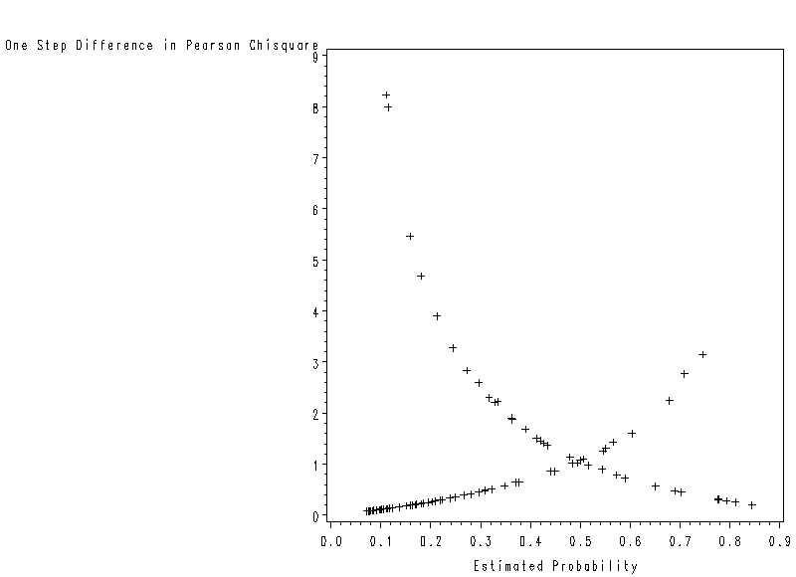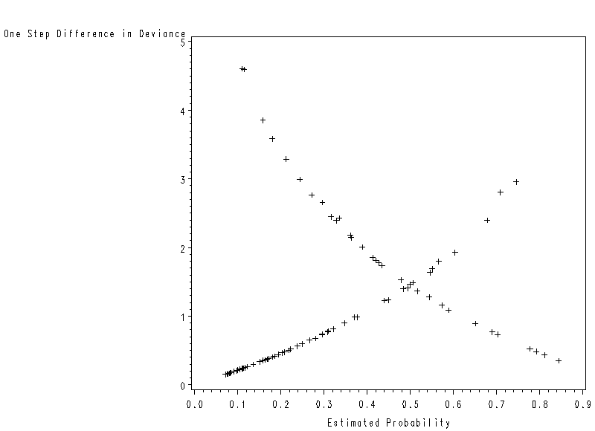
The plots of the delta chi-square and delta deviance statistics against the model-estimated probabilities also show that cases 5 and 14 again stand out – this time in the upper left corner of the plot. The results in the index plots of the delta chi-square and delta deviance statistics in SAS OUTPUT3 and the plots in SAS OUTPUT4 suggest that cases 5 and 14 may substantively affect the conclusions

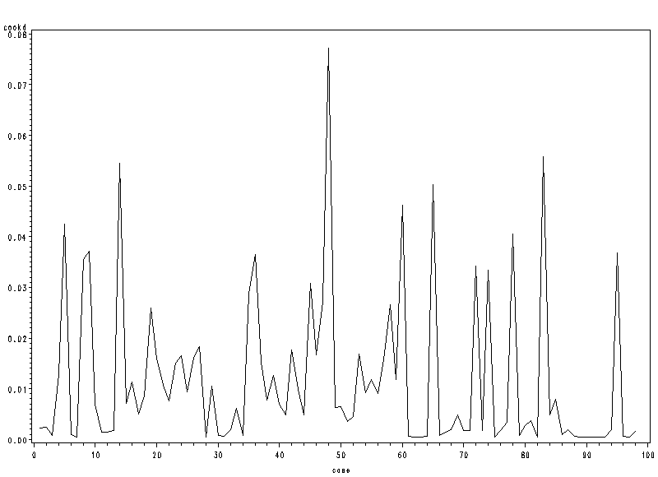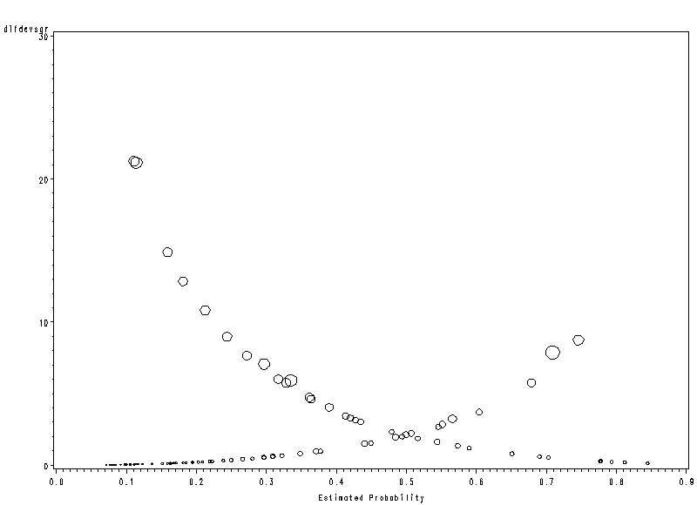
The plot of Cook’s distances indicates that case 48 is indeed the most influential in terms of effect on the linear predictor. Note that cases 5 and 14 – previously identified as most influential in terms of their effect on the Pearson chi-square and deviance statistics- have relatively less influence on the linear predictor. This is shown also by the proportional-influence plot. The plot symbols for these cases are not overly large, indicating that these cases are not particularly influential in terms of the fitted linear predictor values. Case 48 was temporarily deleted and the logistic regression fit was obtained. The results were not appreciably different from those obtained from the full data set, and the case was retained.
Inferences about Mean Response
For the disease outbreak example, what is the probability of 10-year-old persons of lower socioeconomic status living in city sector 1 having contracted the disease?
Pointer Estimator:
Denote the vector of the levels of the X variables for which π is to be estimated by X_{h}:
$X_{h}=\left[\begin{matrix}1 \\ X_{\text{h1}} \\ X_{\text{h2}} \\ ⋮ \\ X_{\text{h,p}−1}\end{matrix}\right]$ The point estimator of π_{h} will be denoted by ${\hat{π}}_{h}=[1+\text{exp}(−X_{h}'b)]^{−1}$
where b is the vector of estimated regression coefficients.
Interval Estimation
Step 1: calculate confidence limits for the logit mean response $π_{h}'$.
$$\begin{aligned}{\hat{π}}_{h}^{'}=X_{h}^{'}b,{\text{ s}}^{2}\left\{{\hat{π}}_{h}^{'}\right\}=X_{h}^{'}s^{2}\left\{b\right\}X_{h}, \\ {\text{ where s}}^{2}\left\{b\right\}\text{ is the estimated approximate variance-covariance matrix of }b\text{ in }(\text{14}\text{.}\text{51}) \\ \text{ of text ALSM when n is large}\end{aligned}$$

Approximate 1-α large-sample confidence limits for the logit mean response $π_{h}'$ are:
$$\begin{aligned}L={\hat{π}}_{h}^{'}−z(\text{1-}α/2)s\left\{{\hat{π}}_{h}^{'}\right\} \\ U={\hat{π}}_{h}^{'}+z(\text{1-}α/2)s\left\{{\hat{π}}_{h}^{'}\right\}\end{aligned}$$
Step 2: From the fact that $π_{h}=[1+\text{exp}(−π_{h}^{'})]^{−1}$, the approximate 1-α large-sample confidence limits L* and U* for the mean response $π_{h}$ are:
$$\begin{aligned}L∗[1+\text{exp}(−L)]^{−1} \\ U∗[1+\text{exp}(−U)]^{−1}\end{aligned}$$
Simultaneous Confidence Intervals for Several Mean Responses
When it is desired to estimate several mean response π_{h} corresponding to different X_{h} vectors with family confidence coefficient 1-α, Bonferroni simultaneous confidence intervals may be used.
Step 1: The g simultaneous approximate 1-α large-sample confidence limits for the logit mean response $π_{h_{k}}'$ are:
$\begin{aligned}L={\hat{π}}_{h_{k}}^{'}−z(\text{1-}α/2g)s \\ \end{aligned}$
Step 2: The g simultaneous approximate 1-α large-sample confidence limits for the mean response $π_{h_{k}}$ are:
$\begin{aligned}L∗[1+\text{exp}(−L)]^{−1} \\ U∗[1+\text{exp}(−U)]^{−1}\end{aligned}$
Example (disease outbreak)
- It is desired to find an approximate 95 percent confidence interval for the probability π_{h} that persons 10 years old who are of lower socioeconomic status and live in sector 1 have contracted disease.
/*the outest= and covout options create*/  /*a data set that contains parameter */  /*estimates and their covariances for */  /*the model fitted*/  proc logistic data=ch14ta03 outest=betas covout;  model y (event='1')= x1 x2 x3 x4 /covb;  run;  /*add column for zscore*/  data betas;  set betas;  zvalue=probit(0.975);  run;  proc iml;  use betas;  read all var {'Intercept'} into a1;  read all var {'x1'} into a2;  read all var {'x2'} into a3;  read all var {'x3'} into a4;  read all var {'x4'} into a5;  read all var {'zvalue'} into zvalue; | /*define the b vector*/  b=t(a1[1]||a2[1]||a3[1]||a4[1]||a5[1]);  /*define variance-covariance matrix for b*/  covb=(a1[2:6]||a2[2:6]||a3[2:6]||a4[2:6]||a5[2:6]);  /*Define xh matrix*/  xh={1,10,0,1,0};  /*find the point estimator of logit mean*/  /* based on equation above the equation */  /*(14.91) on page 602 of text ALSM*/  logitpi=xh`*b;  /*find the estimated variance of logitpi*/  /*based on the equation (14.92)on page 602*/  /*of text ALSM*/  sbsqr=xh`*covb*xh;  /*find confidence limit for logit mean*/  L=logitpi-zvalue*sqrt(sbsqr);  U=logitpi+zvalue*sqrt(sbsqr);  L=L[1];  U=U[1];  /*find confidence limit L* and U* for*/  /*probability based on equation on page 603*/  /*of text ALSM*/  Lstar=1/(1+EXP(-L));  Ustar=1/(1+EXP(-U));  print L U Lstar Ustar;  quit;  SAS OUTPUT  L U LSTAR USTAR  -3.383969 -1.256791 0.0328002 0.2215268

Prediction of a New Observation

1. Choice of Prediction Rule
$\text{outcome}=\left\{{\begin{matrix}1\text{ if \{}\hat{π}\end{matrix}}_{\text{h }}\text{is large} | | 0\text{ if \{}\hat{π} | | \text{h }\text{is small} | \right.$ Where is the cutoff point?
- Use .5 as the cutoff
$\text{outcome}=\left\{{\begin{matrix}1\text{ if \{}\hat{π}\end{matrix}}_{\text{h }}>\text{.}5 | | 0\text{ if \{}\hat{π} | | \text{h }≤\text{.}5 | \right.$ ⬅(a) it is equally likely in the population of interest that
outcomes 0 and 1 will occur; and
(b) the costs of incorrectly predicting 0 and 1 are
approximately the same
- Find the best cutoff for the data set on which the multiple logistic regression model is based.
For each cutoff, the rule is employed on the n cases in the model-building data set and the proportion of cases incorrectly predicted is ascertained. The cutoff for which the proportion of incorrect predictions is lowest is the one to be employed.
⬅ (a) the data set is a random sample from the relevant population, and thus reflects the proper proportions of 0s and 1s in the population
(b) the costs of incorrectly predicting 0 and 1 are approximately the same
(3) Use prior probabilities and costs of incorrect predictions in determining the cutoff.
⬅(a) prior information is available about the likelihood of 1s and 0s in the population
(b) the data set is not a random sample from the population
(c) the cost of incorrectly predicting outcome 1 differs substantially from the cost of incorrectly predicting outcome 0.
For the disease outbreak example, we assume that the cost of incorrectly predicting that a person has contracted the disease is about the same as the cost of incorrectly predicting that a person has not contracted the disease. Since a random sample of individual was selected in the two city sectors, the 98 cases in the study constitute a cross section of the relevant population. Consequently, information is provided in the sample about the proportion of persons who have contracted the disease in the population. Here we wish to obtain the best cutoff point for predicting the new observation will be “1” or “0”. | First rule: $\text{outcome}=\left\{{\begin{matrix}1\text{ if \{}\hat{π}\end{matrix}}_{\text{h }}≥\text{.}\text{316} | | 0\text{ if \{}\hat{π} | | \text{h }<\text{.}\text{316} | \right.$  The estimated proportion of persons who had contracted the disease is 31/98=.316  Second rule: $\text{outcome}=\left\{{\begin{matrix}1\text{ if \{}\hat{π}\end{matrix}}_{\text{h }}≥\text{.}\text{325} | | 0\text{ if \{}\hat{π} | | \text{h }<\text{.}\text{325} | \right.$  This is the optimal cutoff
SAS CODE:  /*save the predicted probability */  /*in a variable named yhat*/  /*(p=yhat) and then set newgp=1*/  /*if yhat is greater than or */  /*equal to 0.316,otherwise*/  /* newgp=0. We then form a 2 by 2*/ /*table of Y values (disease */  /*versus nondiseased) by newgp */  /*values (predicted diseased */  /*versus predicted nondiseases)*/  /* the outroc option on the model*/  /*statement saves the data */  /*necessary to produce the ROC*/  /*curve in a data file named roc*/  /*(outroc=roc). Two of the */  /*variables stored in roc data*/  /*are _sensit_(sensitivity)*/  /*and _1mspec_(1-specificity)*/  /*In the proc gplot we plot */  /*_sensit_ against _1mspec_*/  /* to form the ROC curve*/  proc logistic data=ch14ta03 descending;  model y=x1 x2 x3 x4/outroc=roc;  output out=results p=yhat;  run;  data results;  set results;  if yhat ge .316 then newgp=1; else newgp=0;  proc freq data=results;  table y*newgp/ nopercent norow nocol;  run;  /*ROC curve*/  proc gplot data=roc;  symbol1 color=black value=none interpol=join;  plot _SENSIT_*_1MSPEC_;  run; | SAS OUTPUT:  The FREQ Procedure  Table of y by newgp  y newgp  Frequency‚ 0‚ 1‚ Total  ƒƒƒƒƒƒƒƒƒˆƒƒƒƒƒƒƒƒˆƒƒƒƒƒƒƒƒˆ  0 ‚ 49 ‚ 18 ‚ 67  ƒƒƒƒƒƒƒƒƒˆƒƒƒƒƒƒƒƒˆƒƒƒƒƒƒƒƒˆ  1 ‚ 8 ‚ 23 ‚ 31  ƒƒƒƒƒƒƒƒƒˆƒƒƒƒƒƒƒƒˆƒƒƒƒƒƒƒƒˆ  Total 57 41 98  There were 8+23=31 (false negatives+true positives)diseased individuals and 49+19=67 (true negatives +false positives) non-diseased individuals. The fitted regression function correctly predicted 23 of the 31 diseased individuals. Thus the sensitivity is calculated as true positive/(false negative+true positive)=23/31=0.7419 as reported on text page 606. The logistic regression function’s specificity is defined as true negative/(false positive+true negative)=49/67=0.731. This is not consistent with text page 607 where the specificity is reported as 47/67=0.7014. The difference comes from the regression model fitted. We fit the regression model based on using age, status and sector as predictor. In text, they fit the regression model based on using age and sector only.

Validation of Prediction Error Rate
The reliability of the prediction error rate observed in the model-building data set is examined by applying the chosen prediction rule to a validation data set. If the new prediction error rate is about the same as that for the model-building data set, then the latter gives a reliable indication of the predictive ability of the fitted logistic regression model and the chosen prediction rule. If the new data lead to a considerably higher prediction error rate, then the fitted logistic regression model and the chosen prediction rule do not predict new observations as well as originally indicated.

For the disease outbreak example, the fitted logistic regression function based on the model-building data set is
$$\hat{π}=[1+\text{exp}(−3\text{.}\text{8877}−\text{.}\text{02975}X_{1}−\text{.}\text{4088}X_{2}+\text{.}\text{30525}X_{3}−1\text{.}\text{5747}X_{4})]^{−1}$$
We use this fitted logistic regression function to calculate estimated probabilities ${\hat{π}}_{h}$for cases 99-196 in the disease outbreak data set in Appendix C.10. The chosen prediction rule is $\text{outcome}=\left\{{\begin{matrix}1\text{ if \{}\hat{π}\end{matrix}}_{\text{h }}≥\text{.}\text{325} | | 0\text{ if \{}\hat{π} | | \text{h }<\text{.}\text{325} | \right.$,
We want to classify observations in the validation data set.
data disease;  infile 'c:\stat231B06\appenc10.txt';  input case age status sector y other ;  x1=age;  /*code the status with two dummy var*/  if status eq 2 then x2=1; else x2=0;  if status eq 3 then x3=1; else x3=0;  /*code sector with one dummy var*/  if sector eq 2 then x4=1; else x4=0;  /*calculate estimated probabilities*/  /*based on fitted logistic model*/  yhat=(1+exp(2.3129-(0.02975*x1)-(0.4088*x2)+(0.30525*x3)-(1.5747*x4)))**-1;  /*make group predictions based on */  /*the specified prediction rule*/  if yhat ge .325 then newgp=1; else newgp=0;  run;  /*generate the frequency table for */  /*the validation data set */  /*(cases 98-196)*/  proc freq;  where case>98;  table y*newgp/nocol nopct;  run; | The FREQ Procedure  Table of y by newgp  y newgp  Frequency‚  Row Pct ‚ 0‚ 1‚ Total  ƒƒƒƒƒƒƒƒƒˆƒƒƒƒƒƒƒƒˆƒƒƒƒƒƒƒƒˆ  0 ‚ 44 ‚ 28 ‚ 72  ‚ 61.11 ‚ 38.89 ‚  ƒƒƒƒƒƒƒƒƒˆƒƒƒƒƒƒƒƒˆƒƒƒƒƒƒƒƒˆ  1 ‚ 12 ‚ 14 ‚ 26  ‚ 46.15 ‚ 53.85 ‚  ƒƒƒƒƒƒƒƒƒˆƒƒƒƒƒƒƒƒˆƒƒƒƒƒƒƒƒˆ  Total 56 42 98  The off-diagonal percentages indicate that 12(46.2%) of the 26 diseased individuals were incorrectly classified (prediction error) as non-diseased. Twenty-eight (38.9%) of the 72 non-diseased individuals were incorrectly classified as diseased. Note that the total prediction error rate of 40.8% =(28+12)/98 is considerably higher than the 26.5% error rate based on the model-building data set. Therefore the fitted logistic regression model and the chosen prediction rule do not predict new observations as well as originally indicated.

