Random and Mixed-Effects Model

Model II (Random Factor Levels) for Two-factor Studies
What we have considered:

$\underset{\text{specific}\text{ factor levels chosen}}{\text{Fixed Effect Model}}\left\{\begin{matrix}\text{ Interest centers on the effects of the specific factor levels chosen} \\ \\ \text{Statistical inferences is confined to these specific levels studied}\end{matrix}\right.$
What if a factor has a large number of possible levels and interest centers on the effects of all possible levels? Keep in mind that measuring responses at every level may be difficult, impossible, or prohibitively expensive.
Solution:
- Regard the set of all levels under consideration as a statistical population
- Draw conclusions about this population on the basis of the observed responses to a random sample of levels selected from this population.

$$\underset{\text{nonSpecific}\text{ factor levels chosen}}{\text{Random}\text{ Effect Model}}$$

Example: A company owns several hundred retail stores, seven of these stores were selected at random, and a sample of employees in each store was asked to evaluate the management of the store.

- The seven stores chosen for the study constitute the seven levels of the random factor, retail stores.
- Management was not just interested in the management of the seven stores chosen, but wanted to generalize the results to the entire population of stores.

One-way random effects model

$Y_{\text{ij}}=μ_{i}+ε_{\text{ij}}$ (1) (cell means model)
i=1 ,r ; j=1 ,n

$Y_{\text{ij}}=μ+τ_{i}+ε_{\text{ij}}$ (2) (factor effect model)
i=1 ,r ; j=1 ,n
where:
u_{i} = the effect of the i-th randomly selected treatment, are independent N(0, $σ_{μ}^{2})$
ε_{ij} =random error, are independent N(0, $σ^{2})$
μ_{i} and ε_{ij} are mutually independent
-----------------------------------------------------------------------------------------------------
μ= the overall mean expected response.
τ_{i} = the effect of the i-th randomly selected treatment, are independent N(0, $σ_{τ}^{2})$
τ_{i} and ε_{ij} are mutually independent

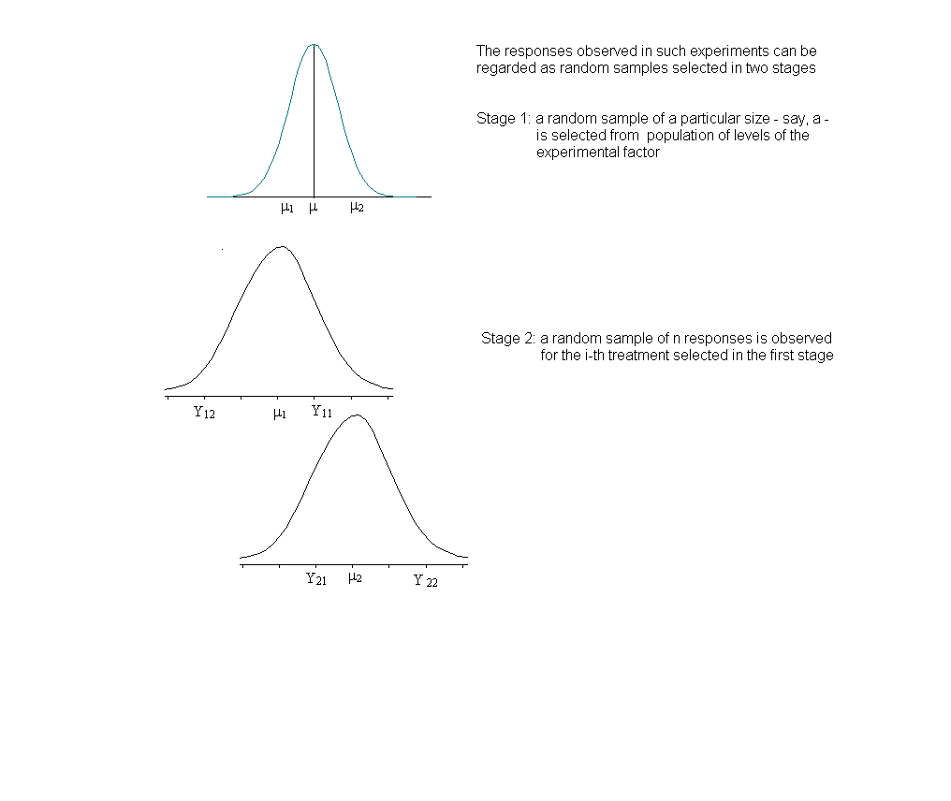
Questions of Interest
- estimation of μ
- estimation of σ²
- estimation of $σ_{μ}^{2}$
- estimation of $σ_{μ}^{2}$/( σ²+$σ_{μ}^{2}$)
- $$H_{0}:σ_{μ}^{2}=0$$
$H_{1}:σ_{μ}^{2}>0$

Table 10.1 ANOVA Table: one-way random effect model with equal replication

Source of Variation Degree of Sum of Mean
Freedom Squares Square F_{o}
Treatments a-1 $n\sum_{i=1}^{a}{({\overline{Y}}_{i\text{.}}−{\overline{Y}}_{\text{.}\text{.}})^{2}}=\sum_{i=1}^{a}{\frac{Y_{i\text{.}}^{2}}{n}−\frac{Y_{\text{.}\text{.}}^{2}}{\text{an}}}$ MS_{Treatment} $F_{o}=\frac{{\text{MS}}_{\text{Treatment}}}{{\text{MS}}_{E}}$

Error a(n-1) $\sum_{i=1}^{a}{\sum_{j=1}^{n}{(Y_{\text{ij}}−{\overline{Y}}_{i\text{.}})^{2}}}$ MS_{E}
Total an-1 $\sum_{i=1}^{a}{\sum_{j=1}^{n}{(Y_{\text{ij}}−{\overline{Y}}_{\text{.}\text{.}})^{2}}=\sum_{i=1}^{a}{\sum_{j=1}^{n}{Y_{\text{ij}}^{2}}−\frac{Y_{\text{.}\text{.}}^{2}}{\text{an}}}}$

The expected values of these mean squares are known as

$$E({\text{MS}}_{E})=σ^{2}, E({\text{MS}}_{\text{Treatment}})=σ^{2}+{nσ}_{μ}^{2}$$

Estimation of μ

$$\hat{μ}={\bar{Y}}_{\text{.}\text{.}}$$
$$V({\bar{Y}}_{\text{.}\text{.}})=\frac{σ_{μ}^{2}}{r}+\frac{σ^{2}}{\text{rn}}=\frac{{\text{nσ}}_{μ}^{2}+σ^{2}}{\text{rn}}$$
$$s^{2}\left\{{\bar{Y}}_{\text{.}\text{.}}\right\}=\frac{{\text{MS}}_{\text{Treatment}}}{\text{rn}}$$

The confidence limits for μ: ${\bar{Y}}_{\text{.}\text{.}}±t_{1−\text{α/2,r}−1}s\left\{{\bar{Y}}_{\text{.}\text{.}}\right\}$

Estimation of $σ_{μ}^{2}$/( σ²+$σ_{μ}^{2}$)

$P(F_{α/2,r−1,r(n−1)}≤\frac{{\text{MS}}_{\text{Treatment}}}{{\text{MS}}_{E}}\frac{σ^{2}}{({nσ}_{μ}^{2}+σ^{2})}≤F_{1−α/2,r−1,r(n−1)})=1−α$$\frac{{{\text{MS}}_{\text{Treatment}}}/({nσ}_{μ}^{2}+σ^{2})}{{{\text{MS}}_{E}}/{σ^{2}}}\text{\sim }F_{r−1,r(n−1)}$

$\begin{aligned}P(L≤\frac{σ_{μ}^{2}}{σ^{2}}≤U)=1−α \\ \text{Where} \\ L=\frac{1}{n}(\frac{{\text{MS}}_{\text{Treatments}}}{{\text{MS}}_{E}}\frac{1}{F_{1−α/2},r−1,r(n−1)}−1), \\ U=\frac{1}{n}(\frac{{\text{MS}}_{\text{Treatments}}}{{\text{MS}}_{E}}\frac{1}{F_{α/2},r−1,r(n−1)}−1), \\ \end{aligned}$

$$\frac{L}{L+1}≤\frac{σ_{τ}^{2}}{σ_{τ}^{2}+σ^{2}}≤\frac{U}{1+U}$$

Example: Apex enterprises studied personnel officer evaluation ratings of potential employees. Five of the company’s personnel officers were randomly selected, and four job applicants were randomly assigned to each of the five officers. Thus each officer rated four job applicants.
  Obs | y | officer | Candidate
  1 | 76 | 1 | 1
  2 | 65 | 1 | 2
  3 | 85 | 1 | 3
  4 | 74 | 1 | 4
  5 | 59 | 2 | 1
  .
SAS CODE:
data apex;
infile 'c:\stat231B06\ch25ta01.txt';
input y officer candidate;
run;

proc glm;
class officer;
model y=officer;
/*because the five officers are perceived as a random sample from a */
/*very large "population" of officers, we refer to the factor officers*/
/*as a random factor*/
random officer;
run;
/*To construct confidence intervals for functions of sigma^2,etc.,*/
/*and carry out additional analyses, we use SAS proc mixed. Note that*/ /*the 'method'option can be used to specify the estimation method */
/*[ml=maximum likelihood, reml=residul(restricted)maximum likelihood),*/
/*miqvue0=minimum variance quadratic unbiased estimates. for the */
/*covariance parameters*/
proc mixed method =reml asycov cl covtest
alpha=.1;
class officer;
/*estimate the mean rating of all personnel officers with a 90% *
/*confidence interval*/
model y= / cl alpha=.1;
random officer;
run;

data ratio;
/*use text equation 25.18*/
n=4;
r=5;
mstr=394.925;
mse=73.28333;
fl=finv(1-0.1, r-1, r*(n-1));
fu=finv(0.1, r-1, r*(n-1));
l=1/n*((mstr/mse)*(1/fl)-1);
u=1/n*((mstr/mse)*(1/fu)-1);
lstar=l/(l+1);
ustar=u/(u+1);
proc print data=ratio;
var l u lstar ustar;
run;
SAS OUTPUT:
The GLM Procedure

Dependent Variable: y

Sum of
Source DF Squares Mean Square F Value Pr > F

Model 4 1579.700000 394.925000 5.39 0.0068

Error 15 1099.250000 73.283333

Corrected Total 19 2678.950000

R-Square Coeff Var Root MSE y Mean

0.589671 11.98120 8.560569 71.45000

Source DF Type I SS Mean Square F Value Pr > F

officer 4 1579.700000 394.925000 5.39 0.0068

Source DF Type III SS Mean Square F Value Pr > F

officer 4 1579.700000 394.925000 5.39 0.006
We conclude that the means for officers in the population (of officers) are not all equal because p-value=0.006.

Solution for Fixed Effects

Standard
Effect Estimate Error DF t Value Pr > |t| Alpha Lower Upper

Intercept 71.4500 4.4437 4 16.08 <.0001 0.1 61.9768 80.9232
We estimate the mean rating (μ..) of all personnel officers with a 90% confidence intervals. This is accomplished by the “method y=/cl alpha=.1;” statement. From the Solution for Fixed effects table, the estimate is $\hat{μ}=\text{71}\text{.}\text{45}$and the confidence limit is between 61.98 and 80.92

The Mixed Procedure

Covariance Parameter Estimates

Standard Z
Cov Parm Estimate Error Value Pr Z Alpha Lower Upper

officer 80.4104 70.1333 1.15 0.1258 0.1 29.5215 865.42
Residual 73.2833 26.7593 2.74 0.0031 0.1 43.9774 151.39

Asymptotic Covariance Matrix of Estimates

Row Cov Parm CovP1 CovP2

1 officer 4918.68 -179.01
2 Residual -179.01 716.06
to estimate sigma^2 with a 90% confidence interval, we use proc mixed and requested that the asymptotic covariance matrix of the covariance parameters be displayed and that 90% confidence limits be computed to estimate the parameters (asycov, cl, covtest alpha=.1;). The covtest option produces asymptotic standard errors and Wald Z-test for the covariance parameter estimates. The 90% confidence interval is calculated between 43.98 and 151.39.

Obs l u lstar ustar
1 0.32052 4.96436 0.24272 0.83234

An estimate of σ² is given by MSE=73.28 (see the first output). The lower and upper limits for $\frac{σ_{μ}^{2}}{σ_{μ}^{2}+σ^{2}}$ is between 24.272 and 0.83234

Two or more random effects (Model II)
Suppose both factors A and B are random factors, the two-way complete model with random effects is
$Y_{\text{ijk}}=μ_{\text{.}\text{.}}+α_{i}+β_{j}+(\text{εβ})_{\text{ij}}+ε_{\text{ijk}}$
i=1 ,a
j=1 ,b
k=1,2 . . . n
μ..= the overall mean expected response.
α_{i} = the effect of the i-th randomly selected treatment, are independent N(0, $σ_{α}^{2})$
β_{j} = the effect of the j-th randomly selected treatment, are independent N(0, $σ_{β}^{2})$
αβ_{ij} = the effect of the ij-th randomly selected interaction, are independent N(0, $σ_{\text{αβ}}^{2})$ ε_{ijk} =random error, are independent N(0, $σ^{2})$
α_{i} , β_{j} , αβ_{ij} and ε_{ijk} are pairwise independent

As in a two-way complete model with fixed effects, SS_{Total}= SS_{A} +SS_{B} +SS_{AB} +SS_{E}
and the calculation for each term is the same.

Model II ANOVA table
Source of Degree of Sum of Mean Expected
Variation Freedom Squares Square MS F_{o}
Factor A a-1 SS_{A} MS_{A}$=\frac{{\text{SS}}_{A}}{(a−1)}$ $\begin{aligned}E({\text{MS}}_{A}) \\ σ^{2}+{\text{nσ}}_{αβ}^{2}+{\text{bnσ}}_{α}^{2}\end{aligned}$ $F_{o}=\frac{{\text{MS}}_{A}}{{\text{MS}}_{\text{AB}}}$
Factor B b-1 SS_{B} MS_{B}$=\frac{{\text{SS}}_{B}}{(b−1)}$ $\begin{aligned}E({\text{MS}}_{B}) \\ σ^{2}+{\text{nσ}}_{αβ}^{2}+{\text{anσ}}_{β}^{2}\end{aligned}$ $F_{o}=\frac{{\text{MS}}_{B}}{{\text{MS}}_{\text{AB}}}$

AB (a-1)(b-1) SS_{AB} MS_{AB}$=\frac{{\text{SS}}_{\text{AB}}}{(a−1)(b−1)}$ $\begin{aligned}E({\text{MS}}_{\text{AB}}) \\ σ^{2}+{\text{nσ}}_{\text{αβ}}^{2}\end{aligned}$ $F_{o}=\frac{{\text{MS}}_{\text{AB}}}{{\text{MS}}_{E}}$
interaction
Error ab(n-1) SS_{E} MS_{E}$=\frac{{\text{SS}}_{E}}{\text{ab}(n−1)}$ $E({\text{MS}}_{E})=σ^{2}$
Total abn-1 SS_{Total}
Hypothesis testing:
$H_{0}:σ_{\text{αβ}}^{2}=0$ (no interaction)
$$H_{1}:σ_{\text{αβ}}^{2}>0$$
Reject H₀ if $F_{o}=\frac{{\text{MS}}_{\text{AB}}}{{\text{MS}}_{E}}$>F_{1-α, (a-1)(b-1),ab(n-1)}
When there is no interaction, we can test
$H_{0}:σ_{α}^{2}=0$
$$H_{1}:σ_{α}^{2}>0$$
Reject H₀ if $F_{o}=\frac{{\text{MS}}_{A}}{{\text{MS}}_{\text{AB}}}$>F_{1-α, (a-1),(a-1)(b-1)}
(Note the denominator is not MSE)
We can also test
$H_{0}:σ_{β}^{2}=0$
$$H_{1}:σ_{β}^{2}>0$$
Reject H₀ if $F_{o}=\frac{{\text{MS}}_{B}}{{\text{MS}}_{\text{AB}}}$>F_{α, (b-1),(a-1)(b-1)}
Mixed Models (Model III)
When a model has both fixed effects and random effects, it is called a mixed model. If a factor is random, its interactions with any other factor will be regarded as random effects.
$Y_{\text{ijk}}=μ_{\text{.}\text{.}}+α_{i}+β_{j}+(\text{εβ})_{\text{ij}}+ε_{\text{ijk}}$
i=1 ,a
j=1 ,b
k=1,2 . . . n
μ..= the overall mean expected response.
α_{i} = the effect of the i-th fixed effect , $\sum{α_{i}}=0$
β_{j} = the effect of the j-th randomly selected treatment, are independent N(0, $σ_{β}^{2})$
αβ_{ij} = the effect of the ij-th randomly selected interaction, are independent
N(0,$\frac{a−1}{a}σ_{\text{αβ}}^{2})$, subject to the restrictions:$\sum{{\text{αβ}}_{\text{ij}}}=0$
ε_{ijk} =random error, are independent N(0, $σ^{2})$
β_{j} , αβ_{ij} and ε_{ijk} are pairwise independent

Source of Degree of Sum of Mean Expected
Variation Freedom Squares Square MS F_{o}
Factor A a-1 SS_{A} MS_{A}$=\frac{{\text{SS}}_{A}}{(a−1)}$ $\begin{aligned}E({\text{MS}}_{A}) \\ σ^{2}+{\text{nσ}}_{\text{αβ}}^{2}+\text{bn}\frac{\sum_{i=1}^{a}{α_{i}^{2}}}{a−1}\end{aligned}$ $F_{o}=\frac{{\text{MS}}_{A}}{{\text{MS}}_{\text{AB}}}$
Factor B b-1 SS_{B} MS_{B}$=\frac{{\text{SS}}_{B}}{(b−1)}$ $\begin{aligned}E({\text{MS}}_{B}) \\ σ^{2}+{\text{anσ}}_{β}^{2}\end{aligned}$ $F_{o}=\frac{{\text{MS}}_{B}}{{\text{MS}}_{E}}$

AB (a-1)(b-1) SS_{AB} MS_{AB}$=\frac{{\text{SS}}_{\text{AB}}}{(a−1)(b−1)}$ $\begin{aligned}E({\text{MS}}_{\text{AB}}) \\ σ^{2}+{\text{nσ}}_{αβ}^{2}\end{aligned}$ $F_{o}=\frac{{\text{MS}}_{\text{AB}}}{{\text{MS}}_{E}}$
interaction

Error ab(n-1) SS_{E} MS_{E}$=\frac{{\text{SS}}_{E}}{\text{ab}(n−1)}$ $E({\text{MS}}_{E})=σ^{2}$
Total abn-1 SS_{Total}

Hypothesis testing:

$H_{0}:σ_{\text{τβ}}^{2}=0$ (no interaction)
$$H_{1}:σ_{\text{τβ}}^{2}>0$$

Reject H₀ if $F_{o}=\frac{{\text{MS}}_{\text{AB}}}{{\text{MS}}_{E}}$>F_{1-α, (a-1)(b-1),ab(n-1)}
When there is no interaction, we can test
$H_{0}:σ_{τ}^{2}=0$
$$H_{1}:σ_{τ}^{2}>0$$
Reject H₀ if $F_{o}=\frac{{\text{MS}}_{A}}{{\text{MS}}_{\text{AB}}}$>F_{1-α, (a-1),(a-1)(b-1)}
(Note the denominator is not MSE)
We can also test
$H_{0}:σ_{β}^{2}=0$
$$H_{1}:σ_{β}^{2}>0$$
Reject H₀ if $F_{o}=\frac{{\text{MS}}_{B}}{{\text{MS}}_{E}}$>F_{1-α, (b-1),ab(n-1)}

