Completely Randomized Factorial Design
- Investigations of the simultaneous effects of two or more factors
- Factors are crossed and all sample sizes are equal
What’s the effect on the sales of the product? | Advantage:  - More efficient than one-factor-at-a-time experiments.  - Necessary when interactions may be present to avoid misleading conclusion.  - allow the effects of a factor to be estimated at several levels of the other factors, yielding conclusions that are valid over a range of experimental conditions.  Model:  $Y_{\text{ijk}}=μ\text{.}\text{.}+α_{i}+β_{j}+(\text{αβ})_{\text{ij}}+ε_{\text{ijk}}$  i=1 ,2 . . .a ; j=1 ,2 . . .b ; k=1,2 . . . n  μ..= the overall mean common to all experimental units.  α_{i} =μ_{i.}-μ.. is the main effect of level i of the row factor.  β_{j} =μ_{.j}-μ.. is the main effect of level j of the column factor.  αβ_{ij} ==μ_{ij}-(μ..+α_{i}+β_{j} ) is the effect of interaction between α_{i} and β_{j}.  ε_{ijk} is the component of random variation associated with observation ijk and are assumed to be independently and identically distributed normal random variables with variance $σ_{ε}^{2}$and zero mean.  Constraint: $\sum_{i=1}^{a}{α_{i}}=0;$$\sum_{j=1}^{b}{β_{j}}=0$;$\sum_{j=1}^{b}{{\text{αβ}}_{\text{ij}}}=\sum_{i=1}^{a}{{\text{αβ}}_{\text{ij}}}=0$  .  Two-Factor Factorial Design- data layout  Factor B  1 … b  Note: the order in which the abn observations are taken is selected at random so that this design is a completely randomized design.
  Selling Price (Factor A)  a=3 | 55 cents
  Selling Price (Factor A)  a=3 | 60 cents
  Selling Price (Factor A)  a=3 | 65 cents
  Promotional campaigns  (Factor B)  b=2 | Radio advertising
  Promotional campaigns  (Factor B)  b=2 | Newspaper advertising
  Treatment Description
  (a×b=6)
  1 55 price, radio ad.
  2 60 price, radio ad.
  3 65 price, radio ad.
  4 55 price, newspaper ad.
  5 60 price, newspaper ad.
  6 65 price, newspaper ad.
  Twelve communities throughout the United States, of approximately equal size and similar socioeconomic characteristics, were selected and the treatments were assigned to them at random, such that each treatment was given to two experimental units.
  This is an experimental study because control was exercised in assigning the factor A and factor B levels to the experimental units by means of random assignments of the treatments to the communities.
  1 | Y₁₁₁,..,Y_{11n}  Mean : μ₁₁ |  | Y_{1b1}, . . ,Y_{1bn}  Mean : μ_{1b} | μ_{1.=}$\frac{\sum_{j=1}^{b}{μ_{1j}}}{b}$
  a | Y_{a11} …,Y_{a1n}  Mean : μ_{a1} |  | Y_{ab1}, . . ,Y_{abn}  Mean : μ_{ab} | μ_{a. =}$\frac{\sum_{j=1}^{b}{μ_{\text{aj}}}}{b}$
   | μ_{.1} = $\frac{\sum_{i=1}^{a}{μ_{i1}}}{a}$ |  | μ_{.b}= $\frac{\sum_{i=1}^{a}{μ_{\text{ib}}}}{a}$ | μ..= $\frac{\sum_{i=1}^{a}{\sum_{j=1}^{b}{μ_{\text{ij}}}}}{\text{ab}}$
Interacting or not Interacting?
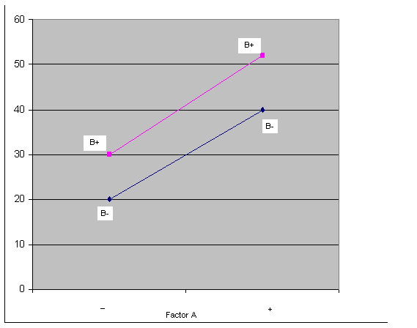  A factorial experiment without interaction | 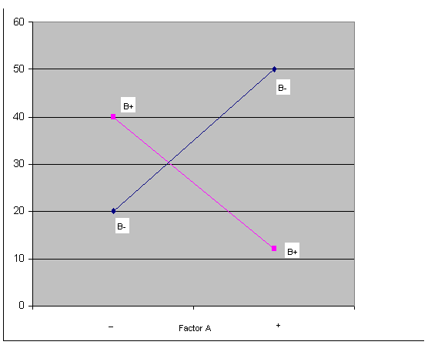  A factorial experiment with interaction

Transformable Interaction or not Transformable Interaction?
Transformable:
Example 1: μ_{ij}=μ..α_{i}β_{j} Multiplicative interactions
➔$\text{log}μ_{\text{ij}}\underset{μ_{\text{ij}}^{'}}{\begin{aligned}↓\end{aligned}}=\text{log}μ_{\text{.}\text{.}}\underset{μ_{\text{.}\text{.}}^{'}}{\begin{aligned}↓\end{aligned}}+\text{log}α_{i}\underset{α_{i}^{'}}{\begin{aligned}↓\end{aligned}}+\text{log}β_{j}\underset{β_{j}^{'}}{\begin{aligned}↓\end{aligned}}$ (interaction removed)

Example 2: $μ_{\text{ij}}=α_{i}+β_{j}+2\sqrt{α_{i}}\sqrt{β_{j}}$ Multiplicative interactions
➔$\sqrt{μ_{\text{ij}}}\underset{μ_{\text{ij}}^{'}}{\begin{aligned}↓\end{aligned}}=\sqrt{α_{i}}\underset{α_{i}^{'}}{\begin{aligned}↓\end{aligned}}+\sqrt{β_{j}}\underset{β_{j}^{'}}{\begin{aligned}↓\end{aligned}}$ (interaction removed)
commonly used transformation:
square, square root, logarithmic, and reciprocal transformations.

Interpreting Interactions?
The interpretation of interactions can be quite difficult when the interacting effects are complex. Only when the interactions have a simple structure, the joint factor effects can be described in a straightforward manner.
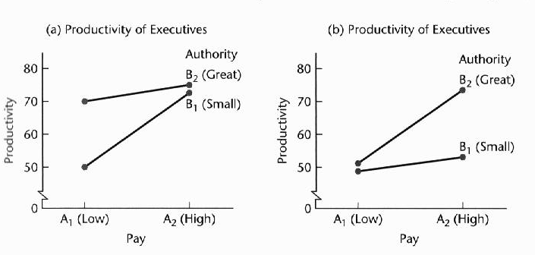
(a) (b)
---raising the pay or increasing the authority ---both higher pay and greater
of low-paid executives with small authority leads to authority are required before
increased productivity any substantial increase in
---combining both higher pay and greater authority productivity takes place
does not lead to any substantial further improvement
in productivity than increasing either one alone.
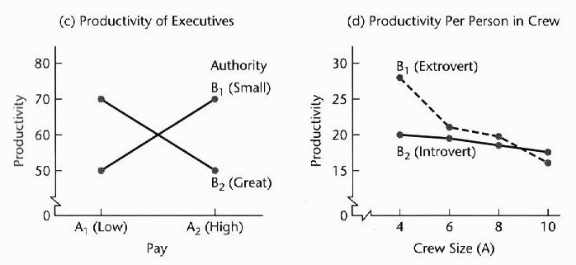
(a) (b)
---neither factor effect is present and the two ----interaction is complex
factors interact (very unusual) -----productivity with an extrovert crew chief
Typically, interaction effects are smaller and a crew of four is substantially larger
than main effects than with an introvert crew chief. The advantage becomes small with crews of
six and eight, and with a crew of 10 an
introvert crew chief leads to a slightly
_{larger productivity}
Model I (Fixed Factor Levels) for Two-factor Studies
_{The basic situation:}
- Factor A is studied at a levels, and there are of intrinsic interest in themselves; in other words, the a levels are not considered to be a sample from a larger population of factor A levels.
- Similarly, factor B is studied at b levels that are of intrinsic interest in themselves.
- All ab factor level combinations are included in the study. The number of cases for each of the ab treatments is the same, denoted by n and it is required that n>1.
- The total number of cases for the study is abn

Models for Two Treatment Factors

If we use the two-digit codes ij for the treatment combinations in the one-way analysis of variance model, we obtain the model

$Y_{\text{ijk}}=μ_{\text{ij}}+ε_{\text{ijk}}$ (1) (cell means model)
i=1,…,a
j=1,…b
k=1,2 . . .,n

$Y_{\text{ijk}}=μ_{\text{.}\text{.}}+τ_{i}+β_{j}+(\text{τβ})_{\text{ij}}+ε_{\text{ijk}}$ (2) (factor effect model)
i=1,…,a
j=1,…,b
k=1,2 . . .,n

μ..= the overall mean common to all experimental units.

α_{i} is the effect of level i of the row factor. (i=1,…,a)

β_{j} is the effect of level j of the column factor. (i=1,…,b)

αβ_{ij} is the effect of interaction between α_{i} and β_{j}.
.
ε_{ijk} is the component of random variation associated with observation ijk and are assumed to be independently and identically distributed normal random variables with variance $σ_{ε}^{2}$and zero mean.

Constraint:
$$\begin{aligned}\sum{α_{i}}=0 \\ \sum{β_{j}}=0 \\ \sum{{\text{αβ}}_{\text{ij}}}=\sum{{\text{αβ}}_{\text{ij}}}=0\end{aligned}$$

Hypotheses:

$$H_{0}:α_{1}=α_{2}=⋯=α_{a}=0$$
$H_{1}:$ at least one $α_{i}≠0$

$$H_{0}:β_{1}=β_{2}=⋯=β_{b}=0$$
$H_{1}:$ at least one $β_{j}≠0$

$H_{0}:(\text{αβ})_{\text{ij}}=0$ for all i,j
$H_{1}:$ at least one ${\text{αβ}}_{\text{ij}}≠0$

Fitting of ANOVA model

$Y_{\text{ijk}}=μ_{\text{ij}}+ε_{\text{ijk}}$ (1) (cell means model)

$Y_{\text{ijk}}=μ_{\text{.}\text{.}}+α_{i}+β_{j}+(\text{αβ})_{\text{ij}}+ε_{\text{ijk}}$ (2) (factor effect model)
i=1 ,a
j=1 ,b
k=1,2 . . . n

Fitting the two-factor cell means model (1) to the sample data by least squares method leads to minimizing the criterion:

$Q_{1}=\sum_{i}{\sum_{j}{\sum_{k}{(Y_{\text{ijk}}−μ_{\text{ij}})^{2}}}}$➔ ${\hat{μ}}_{\text{ij}}={\bar{Y}}_{\text{ij}\text{.}}$ ➔ ${\hat{Y}}_{\text{ijk}}={\hat{μ}}_{\text{ij}}={\bar{Y}}_{\text{ij}\text{.}}$

Fitting the two-factor effect model (2) to the sample data by least squares method leads to minimizing the criterion:
$$Q_{2}=\sum_{i}{\sum_{j}{\sum_{k}{{(Y_{\text{ijk}}−μ_{\text{.}\text{.}}−α_{i}−β_{j}−(\text{αβ})_{\text{ij}})}^{2}}}}$$
subject to the restrictions:
$\sum_{i}{α_{i}=0}\begin{matrix} & \sum_{j}{β_{j}=0\begin{matrix} & \end{matrix}\sum_{i}{{(\text{αβ \{})}_{\text{ij}}}}=\end{matrix}\sum_{j}{{(\text{αβ \{})}_{\text{ij}}}$=0
➔ Parameter Estimator
$\begin{aligned}μ_{\text{.}\text{.}}\begin{matrix} & & \begin{matrix}\begin{matrix}\begin{matrix}\begin{matrix}\begin{matrix} & & \end{matrix} & & \end{matrix} & & \end{matrix} & & \end{matrix} & {\hat{μ}}_{\text{.}\text{.}}={\bar{Y}}_{\text{.}\text{.}\text{.}} & \end{matrix}\end{matrix} \\ α_{i}=μ_{i\text{.}}−μ_{\text{.}\text{.}}\begin{matrix}\begin{matrix}\begin{matrix}\begin{matrix}\begin{matrix} & \end{matrix} & \end{matrix} & & \end{matrix} & & \end{matrix} & & {\hat{α}}_{i}=\end{matrix}{\bar{Y}}_{i\text{.}\text{.}}−{\bar{Y}}_{\text{.}\text{.}\text{.}} \\ β_{j}=μ_{\text{.}j}−μ_{\text{.}\text{.}}\begin{matrix}\begin{matrix}\begin{matrix}\begin{matrix}\begin{matrix} & \end{matrix} & \end{matrix} & & \end{matrix} & & \end{matrix} & & {\hat{β}}_{j}=\end{matrix}{\bar{Y}}_{\text{.}j\text{.}}−{\bar{Y}}_{\text{.}\text{.}\text{.}} \\ (\text{αβ})_{\text{ij}}=μ_{\text{ij}}−μ_{i\text{.}}−μ_{\text{.}j}+μ_{\text{.}\text{.}}\begin{matrix}{\begin{matrix}\begin{matrix}\begin{matrix} & & \end{matrix} & \end{matrix} & α\hat{β}\end{matrix}}_{\text{ij}}={\bar{Y}}_{\text{ij}\text{.}}−{\bar{Y}}_{i\text{.}\text{.}}−{\bar{Y}}_{\text{.}j\text{.}}+{\bar{Y}}_{\text{.}\text{.}\text{.}} & \end{matrix}\end{aligned}$
➔${\hat{Y}}_{\text{ijk}}={\hat{μ}}_{\text{.}\text{.}}+{\hat{α}}_{i}+{\hat{β}}_{j}+α{\hat{β}}_{\text{ij}}={\bar{Y}}_{\text{ij}\text{.}}$
Evaluation of Appropriateness of ANOVA model (Model Adequacy Checking)

Before undertaking formal inference procedures, we need to evaluate the appropriateness of two-factor ANOVA model. The residuals

$$e_{\text{ijk}}=Y_{\text{ijk}}−{\bar{Y}}_{\text{ij}\text{.}}$$
should be examined for normality, constancy of error variance, and independence of error terms in the same fashion as we discussed for linear regression.

Inference of ANOVA model

Table 1. The Analysis of Variance Table for the Two-Factorial Fixed Effects Model

Source of Degree of Sum of Mean
Variation Freedom Squares Square F_{o}
Factor A a-1 SS_{A}=$\text{nb}\sum_{i=1}^{a}{({\overline{Y}}_{i\text{.}\text{.}}−{\overline{Y}}_{\text{.}\text{.}\text{.}})^{2}}=\frac{\sum_{i=1}^{a}{Y_{i\text{.}\text{.}}^{2}}}{\text{bn}}−\frac{Y_{\text{.}\text{.}\text{.}}^{2}}{\text{abn}}$ MS_{A}$=\frac{{\text{SS}}_{A}}{(a−1)}$ $F_{o}=\frac{{\text{MS}}_{A}}{{\text{MS}}_{E}}$
Factor B b-1 SS_{B}=$\text{na}\sum_{i=1}^{a}{({\overline{Y}}_{\text{.}j\text{.}}−{\overline{Y}}_{\text{.}\text{.}\text{.}})^{2}}=\frac{\sum_{j=1}^{b}{Y_{\text{.}j\text{.}}^{2}}}{\text{an}}−\frac{Y_{\text{.}\text{.}\text{.}}^{2}}{\text{abn}}$ MS_{B}$=\frac{{\text{SS}}_{B}}{(b−1)}$ $F_{o}=\frac{{\text{MS}}_{B}}{{\text{MS}}_{E}}$

AB interaction (a-1)(b-1) $\begin{aligned}{\text{SS}}_{\text{AB}}=n\sum_{i=1}^{a}{\sum_{j=1}^{b}{({\bar{Y}}_{\text{ij}\text{.}}−}}{\bar{Y}}_{i\text{.}\text{.}}−{\bar{Y}}_{\text{.}j\text{.}}+{\bar{Y}}_{\text{.}\text{.}\text{.}})^{2} \\ \begin{matrix} & \end{matrix}=\frac{1}{n}\sum_{i=1}^{a}{\sum_{j=1}^{b}{Y_{\text{ij}\text{.}}^{2}}}−\frac{Y_{\text{.}\text{.}\text{.}}^{2}}{\text{abn}}−{\text{SS}}_{A}−{\text{SS}}_{B}\end{aligned}$MS_{AB}$=\frac{{\text{SS}}_{\text{AB}}}{(a−1)(b−1)}$ $F_{o}=\frac{{\text{MS}}_{\text{AB}}}{{\text{MS}}_{E}}$

Error ab(n-1) SS_{E} =$\sum_{i=1}^{a}{\sum_{j=1}^{b}{\sum_{k=1}^{n}{(Y_{\text{ijk}}−{\bar{Y}}_{\text{ij}\text{.}})^{2}}}}$ MS_{E}$=\frac{{\text{SS}}_{E}}{\text{ab}(n−1)}$
Total abn-1 $\sum_{i=1}^{a}{\sum_{j=1}^{b}{\sum_{k=1}^{n}{(Y_{\text{ijk}}−{\bar{Y}}_{\text{.}\text{.}\text{.}})^{2}}}}=\sum_{i=1}^{a}{\sum_{j=1}^{b}{\sum_{k=1}^{n}{Y_{\text{ijk}}^{2}}}−\frac{Y_{\text{.}\text{.}\text{.}}^{2}}{\text{abn}}}$

Strategy for Analysis of Two-Factor Studies

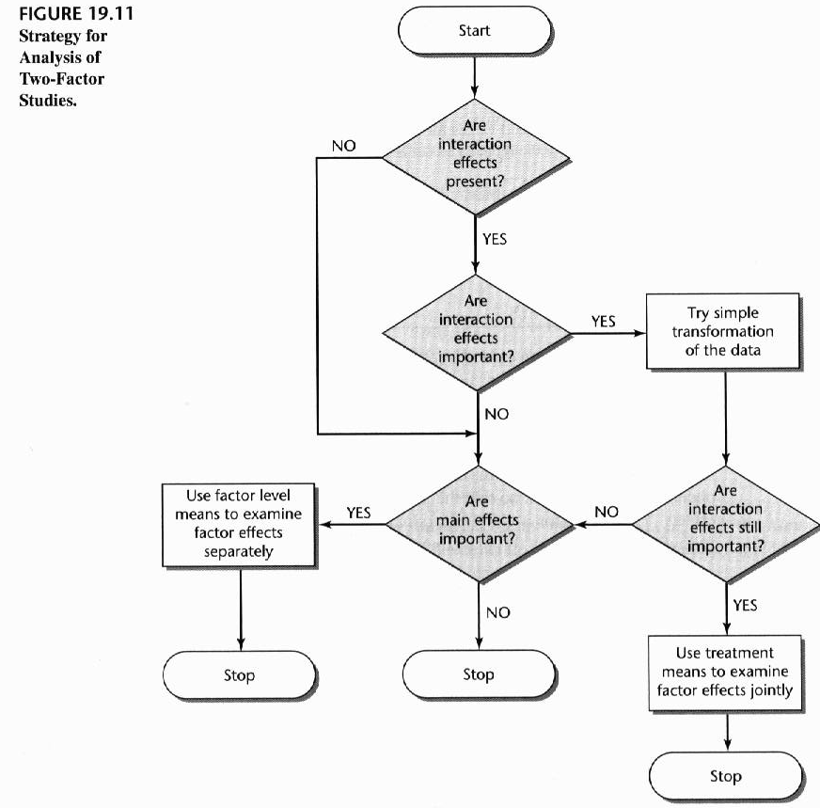

Analysis of Factor Effects in Two-Factor Studies –Equal Sample Size
When the analysis of variance tests indicate the presence of factor effects in two-factor studies, the next step is to analyze the nature of the factor effects including estimation of factor level (Treatment) means and multiple comparisons of factor level (Treatment) means.

- Analysis of Factor Effects when Factors Do Not Interact

- Estimation of Factor Level Mean
$$\begin{aligned}{\hat{μ}}_{i\text{.}}={\bar{Y}}_{i\text{.}\text{.}}\text{==>}\text{var}\left\{{\bar{Y}}_{i\text{.}\text{.}}\right\}=\frac{σ^{2}}{\text{bn}}\text{===>}\overset{\text{by}}{\begin{aligned}\text{Estimated}\end{aligned}}\end{aligned}\frac{\text{MSE}}{\text{bn}}\text{======>}\overset{\text{Limit}}{\begin{aligned}\text{Confidence}\end{aligned}}{\bar{Y}}_{i\text{.}\text{.}}±t_{1−α/2,\text{ab}(n−1)}\sqrt{\frac{\text{MSE}}{\text{bn}}}{\hat{μ}}_{\text{.}j}={\bar{Y}}_{\text{.}j\text{.}}\text{==>}\text{var}\left\{{\bar{Y}}_{\text{.}j\text{.}}\right\}=\frac{σ^{2}}{\text{an}}\text{===>}\overset{\text{by}}{\begin{aligned}\text{Estimated}\end{aligned}}\frac{\text{MSE}}{\text{an}}\text{======>}\overset{\text{Limit}}{\begin{aligned}\text{Confidence}\end{aligned}}{\bar{Y}}_{\text{.}j\text{.}}±t_{1−α/2,\text{ab}(n−1)}\sqrt{\frac{\text{MSE}}{\text{an}}}$$

- Estimation of Contrast of Factor Level Means

$\begin{aligned}Γ_{\text{row}}=\sum{c_{i}μ_{i\text{.}},}\text{where}\sum{c_{i}=0} \\ C_{\text{row}}=\sum{c_{i}{\bar{Y}}_{i\text{.}\text{.}}}\text{==>}\text{var}(C_{\text{row}})=\frac{σ^{2}}{\text{bn}}\sum{c_{i}^{2}}\text{===>} \\ \end{aligned}\overset{\text{by}}{\begin{aligned}\text{Estimated}\end{aligned}}\frac{\text{MSE}}{\text{bn}}\sum{c_{i}^{2}}\text{====>}\overset{\text{Limit}}{\begin{aligned}\text{Confidence}\end{aligned}}C_{\text{row}}±t_{1−α/2,\text{ab}(n−1)}\sqrt{\frac{\text{MSE}}{\text{bn}}\sum{c_{i}^{2}}}Γ_{\text{col}}=\sum{c_{i}μ_{\text{.}j},}\text{where}\sum{c_{i}=0}C_{\text{col}}=\sum{c_{i}{\bar{Y}}_{\text{.}j\text{.}}}\text{==>}\text{var}(C_{\text{col}})=\frac{σ^{2}}{\text{an}}\sum{c_{i}^{2}}\text{===>}\overset{\text{by}}{\begin{aligned}\text{Estimated}\end{aligned}}\frac{\text{MSE}}{\text{an}}\sum{c_{i}^{2}}\text{====>}\overset{\text{Limit}}{\begin{aligned}\text{Confidence}\end{aligned}}C_{\text{col}}±t_{1−α/2,\text{ab}(n−1)}\sqrt{\frac{\text{MSE}}{\text{an}}\sum{c_{i}^{2}}}$
- Multiple Comparisons of Factor Level Means

  - To use the Tukey procedure to conduct all simultaneous tests of the form:
$\begin{aligned}H_{0}:μ_{i\text{.}}=μ_{i^{'}\text{.}} \\ H:μ_{i\text{.}}≠μ_{i^{'}\text{.}}\end{aligned}$ <=> $\begin{aligned}H_{0}:D=μ_{i\text{.}}−μ_{i^{'}\text{.}}=0 \\ H:D=μ_{i\text{.}}−μ_{i^{'}\text{.}}≠0\end{aligned}$
$\hat{D}={\bar{Y}}_{i\text{.}\text{.}}−{\bar{Y}}_{i^{'}\text{.}\text{.}}$; $s\left\{\hat{D}\right\}=\frac{2\text{MSE}}{\text{bn}}$
➔$\text{q*}=\frac{\sqrt{2}\hat{D}}{s\left\{\hat{D}\right\}}$
Tukey’s critical value $q(1−α;a,\text{ab}(n−1))$

Tukey’s test declares two means significantly different if $|q∗|$ > $q(1−α;a,\text{ab}(n−1))$
100(1-α) percent confidence intervals for all pairs of means are

$${\overline{Y}}_{i\text{.}\text{.}}−{\overline{Y}}_{i^{'}\text{.}\text{.}}−q[1−α;a,(n−1)\text{ab}]\sqrt{\frac{\text{MSE}}{\text{an}}}≤μ_{i\text{.}}−μ_{i^{'}\text{.}}≤{\overline{Y}}_{i\text{.}\text{.}}−{\overline{Y}}_{i^{'}\text{.}\text{.}}+q[1−α;a,(n−1)\text{ab}]\sqrt{\frac{\text{MSE}}{\text{an}}}$$

  - To use the Bonferroni procedure to conduct all simultaneous tests of the form:
$\begin{aligned}H_{0}:μ_{i\text{.}}=μ_{i^{'}\text{.}} \\ H:μ_{i\text{.}}≠μ_{i^{'}\text{.}}\end{aligned}$ <=> $\begin{aligned}H_{0}:D=μ_{i\text{.}}−μ_{i^{'}\text{.}}=0 \\ H:D=μ_{i\text{.}}−μ_{i^{'}\text{.}}≠0\end{aligned}$
$\hat{D}={\bar{Y}}_{i\text{.}\text{.}}−{\bar{Y}}_{i^{'}\text{.}\text{.}}$ ➔$\text{t*}=\frac{\hat{D}}{s\left\{\hat{D}\right\}}$
t critical value =t[1-α/2g ;(n-1)ab]

Bonferroni’s test declares two means significantly different if |t*|> t[1-α/2g ;(n-1)ab]

100(1-α) percent confidence intervals for all pairs of means are

$${\overline{Y}}_{i\text{.}\text{.}}−{\overline{Y}}_{i^{'}\text{.}\text{.}}−s\left\{\hat{D}\right\}∗t[1−α/2g;(n−1)\text{ab}]≤μ_{i\text{.}}−μ_{i^{'}\text{.}}≤{\overline{Y}}_{i\text{.}\text{.}}−{\overline{Y}}_{i^{'}\text{.}\text{.}}+s\left\{\hat{D}\right\}∗t[1−α/2g;(n−1)\text{ab}]$$

- To use the Scheffé’s procedure to conduct all contrast tests of the form
$Γ_{u}=c_{1u}μ_{1\text{.}}+c_{2u}μ_{2\text{.}}+⋯+c_{\text{au}}μ_{a\text{.}},$ u=1,2,…m
The estimator of $Γ_{u}$ is
$C_{u}=c_{1u}{\overline{Y}}_{1\text{.}\text{.}}+c_{2u}{\overline{Y}}_{2\text{.}\text{.}}+⋯+c_{\text{au}}{\overline{Y}}_{a\text{.}\text{.}}$ u=1,2,…m
The standard error of $C_{u}$is
$S_{C_{u}}=\sqrt{\frac{\text{MSE}}{\text{bn}}\sum_{i=1}^{a}{(c_{\text{iu}}^{2})}}$
Scheffé’s critical value S_{α,u}=$S_{C_{u}}\sqrt{(a−1)F}$ .
If |C_{u}|> S_{α,u}, the hypothesis that the contrast $Γ_{u}$ equals zero is rejected.
The 100(1-α) percent simultaneous confidence intervals for each contrast is
$C_{u}−S_{α,u}≤Γ_{u}≤C_{u}+S_{α,u}$
- Analysis of Factor Effects when Interactions Are Important
When important interactions exist, the analysis of factor effects generally must be based on the treatment means μ_{ij.}
- Multiple Comparisons of Treatment Means
- To use the Tukey procedure to conduct all simultaneous tests of the form:
$\begin{aligned}H_{0}:μ_{\text{ij}}=μ_{i^{'}j^{'}} \\ H:μ_{\text{ij}}≠μ_{i^{'}j^{'}}\end{aligned}$ <=> $\begin{aligned}H_{0}:D=μ_{\text{ij}}−μ_{i^{'}j^{'}}=0 \\ H:D=μ_{\text{ij}}−μ_{i^{'}j^{'}}≠0\end{aligned}$
$\hat{D}={\bar{Y}}_{\text{ij}\text{.}}−{\bar{Y}}_{i^{'}j'\text{.}}$; $s\left\{\hat{D}\right\}=\frac{2\text{MSE}}{n}$
➔$\text{q*}=\frac{\sqrt{2}\hat{D}}{s\left\{\hat{D}\right\}}$
Tukey’s critical value $q(1−α;\text{ab},\text{ab}(n−1))$
Tukey’s test declares two means significantly different if $|q∗|$ > $q(1−α;\text{ab},\text{ab}(n−1))$
100(1-α) percent confidence intervals for all pairs of means are

$${\overline{Y}}_{\text{ij}\text{.}}−{\overline{Y}}_{i^{'}j'\text{.}}−q[1−α;\text{ab},(n−1)\text{ab}]\sqrt{\frac{\text{MSE}}{n}}≤μ_{\text{ij}\text{.}}−μ_{i^{'}j'\text{.}}≤{\overline{Y}}_{i\text{.}\text{.}}−{\overline{Y}}_{i^{'}\text{.}\text{.}}+q[1−α;\text{ab},(n−1)\text{ab}]\sqrt{\frac{\text{MSE}}{n}}$$
- To use the Scheffé’s procedure to conduct all contrast tests of the form
$Γ_{u}=\sum_{i=1}^{a}{\sum_{j=1}^{b}{c_{\text{iju}}μ_{\text{iju}}}}$ u=1,2,…m
The estimator of $Γ_{u}$ is
$C_{u}=\sum_{i=1}^{a}{\sum_{j=1}^{b}{c_{\text{iju}}{\bar{Y}}_{\text{ij}\text{.}}}}$ u=1,2,…m
The standard error of $C_{u}$is
$S_{C_{u}}=\sqrt{\frac{\text{MSE}}{n}\sum_{i=1}^{a}{\sum_{j=1}^{b}{c_{\text{iju}}^{2}}}}$➔$F∗\frac{C_{u}^{2}}{(\text{ab}−1)s^{2}\left\{C_{u}\right\}}$
Scheffé’s critical value $F$
If |F*|> $F$ the hypothesis that the contrast $Γ_{u}$ equals zero is rejected.

The 100(1-α) percent simultaneous confidence intervals for each contrast is
$C_{u}−\text{Ss}\left\{C_{u}\right\}≤Γ_{u}≤C_{u}+\text{Ss}\left\{C_{u}\right\}$, where S²=(ab-1) $F$

Example: The Castle Bakery Company supplies wrapped Italian bread to a large number of supermarkets in a metropolitan area. An experimental study was made of the effects of height of the shelf display ( factor A: bottom, middle, top) and the width of the shelf display (factor B: regular, wide) on sales of this bakery’s bread during the experimental period (Y, measured in cases). Twelve supermarkets, similar in terms of sales volume and clientele, were utilized in the study. The six treatments were assigned at random to two stores each according to a completely randomized design, and the display of the bread in each store followed the treatment specifications for that store. Sales of the bread were recorded, and these results are presented in the following table.

Factor A  (display height i) | Factor B (display width j)  Regular Wide
Bottom | 47 46  43 40
Middle | 62 67  68 71
Top | 41 42  39 46

SAS CODE:
data bread;
infile 'c:\stat231B06\ch19ta07.txt';
input cases height width;
run;
proc glm data=bread;
class height width;
model cases= height width height*width;
means height;
means height/Tukey cldiff;/*Tukey procedure and confidence limit*/
output out=outbread r=resid p=pred;
run;

proc univariate data=outbread noprint; /* Specify the dataset, do not give standard output*/
qqplot resid ; /* Produce normal probability plot */
run;
quit;

proc gplot;
plot resid*pred;
run;
SAS OUTPUT:
The GLM Procedure

Dependent Variable: cases

Sum of
Source DF Squares Mean Square F Value Pr > F

Model 5 1580.000000 316.000000 30.58 0.0003

Error 6 62.000000 10.333333

Corrected Total 11 1642.000000

R-Square Coeff Var Root MSE cases Mean

0.962241 6.303040 3.214550 51.00000

Source DF Type I SS Mean Square F Value Pr > F

height 2 1544.000000 772.000000 74.71 <.0001
width 1 12.000000 12.000000 1.16 0.3226
height*width 2 24.000000 12.000000 1.16 0.3747

Source DF Type III SS Mean Square F Value Pr > F

height 2 1544.000000 772.000000 74.71 <.0001
width 1 12.000000 12.000000 1.16 0.3226
height*width 2 24.000000 12.000000 1.16 0.3747

The GLM Procedure

Level of ------------cases------------
height N Mean Std Dev

1 4 44.0000000 3.16227766
2 4 67.0000000 3.74165739
3 4 42.0000000 2.94392029

The GLM Procedure

Tukey's Studentized Range (HSD) Test for cases

NOTE: This test controls the Type I experimentwise error rate.

Alpha 0.05
Error Degrees of Freedom 6
Error Mean Square 10.33333
Critical Value of Studentized Range 4.33902
Minimum Significant Difference 6.974

Comparisons significant at the 0.05 level are indicated by ***.

Difference
height Between Simultaneous 95%
Comparison Means Confidence Limits

2 - 1 23.000 16.026 29.974 ***
2 - 3 25.000 18.026 31.974 ***
1 - 2 -23.000 -29.974 -16.026 ***
1 - 3 2.000 -4.974 8.974
3 - 2 -25.000 -31.974 -18.026 ***
3 - 1 -2.000 -8.974 4.974

(a)Analyze the data and draw conclusions. Use α =0.05
First, we begin by testing whether or not interaction effects are present:
$H_{0}:(\text{αβ})_{\text{ij}}=0$ for all i,j
$H_{1}:$ at least one ${\text{αβ}}_{\text{ij}}≠0$
Test Statistic: F*=$\frac{\text{12}}{\text{10}\text{.}3}=1\text{.}\text{16}$
Decision rule: If F*>F_{0.05,2,6}=5.15 or p-value<0.05, reject H₀
Conclusion: since F*=1.17<5.15 (or you can say p-value=0.37<0.05), we do not reject H₀ and conclude that display height and display width do not interact in their effects on sales.
Second, we turn to test for display height main effect and display width main effect.
Flowing the similar testing procedure as above, we conclude that only display height has an effect on sales.

(b)Prepare appropriate residual plots and comment on the model’s adequacy
A plot of the residuals against the fitted values doesn’t show any strong evidence of unequal error variances. A normal probability plot of the residuals is moderately linear. The model assumption appears to be reasonable.

(c) Test simultaneously all pairwise differences among the shelf height means and summarize your findings. Using the Tukey multiple comparison procedure with family significance level α=0.05. Estimate how much greater are mean sales at the middle shelf height than at either of the other two shelf heights

$${\begin{aligned}{{\bar{Y}}_{3\text{.}\text{.}}\text{ \{}\bar{Y}}_{1\text{.}\text{.}}\text{ \{}\bar{Y}\end{aligned}}_{2\text{.}\text{.}}\text{42}\begin{matrix} & \text{44}\begin{matrix} & \text{67}\end{matrix}\end{matrix}$$
__________
It can be concluded from the tests with family significance level α=0.05 that for the product studied and the types of stores in the experiment, the middle shelf height is far better than either the bottom or the top heights and that the latter two do not differ significantly in sales effectiveness.

$$\begin{aligned}\text{16}=\text{23}−7\text{.}0≤μ_{2\text{.}}−μ_{1\text{.}}≤\text{23}+7\text{.}0=\text{30} \\ \text{18}=\text{25}−7\text{.}0≤μ_{2\text{.}}−μ_{3\text{.}}≤\text{25}+7\text{.}0=\text{32}\end{aligned}$$
With family confidence coefficient of .95, we conclude that mean sales for the middle shelf height exceed those for the bottom shelf height by between 16 and 30 cases and those for the top shelf height by between 18 and 32 cases.

