1.

(a)

(b) Since the plot appears to be a straight line with slope close to 1 and high R² value, the quadratic regression function appears to be a good fit here.

(c) 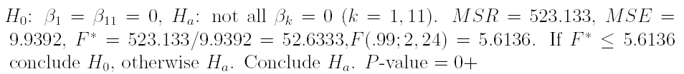

(d)
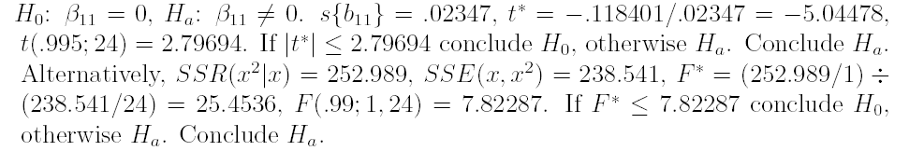

(e)
2.
(a)
refer to page 230 of textbook ALSM for the formula (6.61) for Working-Hotelling simultaneous confidence region and the formula (6.62) for Bonferroni simultaneous confidence region.
In this example,
Working-Hotelling : F(.99; 3, 24)=4.72, therefore W=$\sqrt{3∗4\text{.}\text{72}}=3\text{.}\text{7622}$.
Bonferroni: B=t(0.99833, 24)=3.25756
Therefore, Bonferroni is the more efficient simultaneous estimation procedure for this particular example.

X
10: 20.624873±3.25756*1.895378 14.450564≤E{Y_{h}}≤26.799181
15: 11.508872±3.25756*4.5684127 -3.373007≤E{Y_{h}}≤26.390752
20: -3.527191±3.25756*8.5028604 -31.22577≤E{Y_{h}}≤24.17139

(b)
s{pred}=5.5506391, t(.995,24)=2.7969395,
11.508872±2.7969395(5.5506391) ➔-4.015929≤ Y_{h(new)}≤27.033674

4.
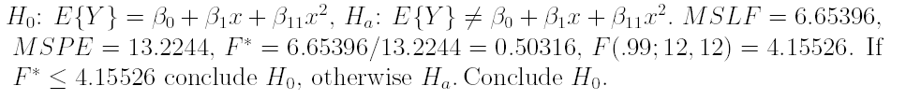

5.
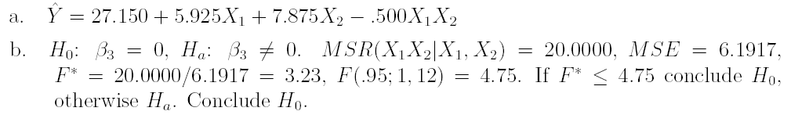

6.

