Entomology/Biology 173
Insect Physiology
Lecture Notes
[Revised April 1, 2002]

Introduction.
References.
Technology Classroom/Textbooks Online/ (Urban Entomology by Walter Ebeling): http://insects.ucr.edu/ent133/ebeling/ebeling.html, Chapter 4. Classes of Arthropod Pests of the Urban Community (pages 90-127).

http://www.austmus.gov.au/biodiversity/factsheets/fs_insec.html

Borror, D. J., C. A. Triplehorn and N. F. Johnson (1992). An Introduction to the Study of Insects, Saunders, Fort Worth.
Chapman, R. F. (1998). The Insects, Structure and Function, 4th edition, Cambridge University Press, NY.
Daly, H. V., J. T. Doyen and A. H. Purcell, III (1998). Introduction to Insect Biology and Diversity, 2nd edition, Oxford University Press, Oxford.
Evans, H. E. (1984). Insect Biology, A Textbook of Entomology, Addison-Wesley, Reading, MA.
Gillott, C. (1995). Entomology, 2nd edition, Plenum Press, NY.
Gullan, P. J. and P. S. Cranston (1994). The Insects: An Outline of Entomology, Chapman & Hall, London.
Romoser, W. S. and J. G. Stoffolano, Jr. (1998). The Science of Entomology, 4th edition, McGraw-Hill, Boston.
Wigglesworth, V. B. (1972). The Principles of Insect Physiology, Chapman & Hall, NY.
Nation, James L. (2002) Insect Physiology and Biochemistry, CRC Press, Boca Raton, FL. 485 pp.

Website for the class.
Entomology/Biology 173 uses Blackboard 5, accessible at www.iLearn.ucr.edu A username and password are needed to log in.

The older (up to 1997) classroom website can be found by selecting wcb for web course in a box, a commercial computer instruction program discontinued in 2001. [http://wcb.ucr.edu/wcb/schools/CNAS/entm/tmiller/2/].

Overview of evolution leading to insect diversity.

Insects comprise 75% of all animal species that scientists have named and described, and most of these insects have wings. The key to insect success is their ability to survive on land and take to the air. The evolution of wings is an obvious key to insect success and diversity because it means that most insects can disperse widely and escape unfavorable environmental changes. Flight also provides a means of escaping predators and allows insects to colonize new environments where they may exploit new food sources.

The existing numbers of species in various groups.

Insects 751,000
Higher Plants 284,000
Other Animals 281,000
Fungi 69,900
Algae 26,900
Protozoa 30,800
Bacteria 4,800
Viruses 1,000

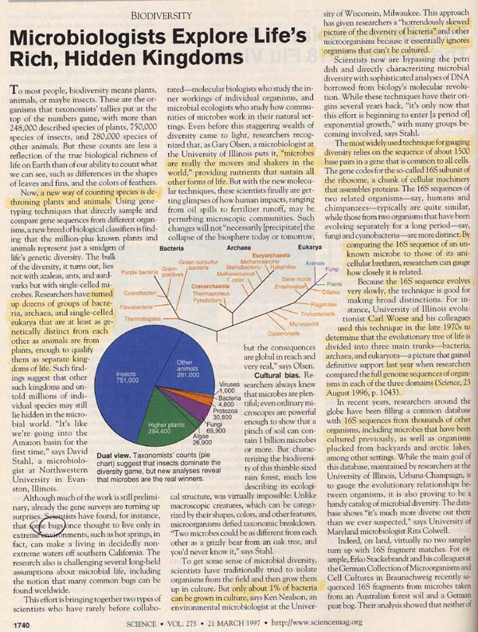

Science, 21 Mar 1997, microbes and insects, p. 1740.

To fully appreciate insects, take a look around the world and see what is living today. The page from Science magazine (shown above) was meant to suggest that bacteria are the most group of organisms on earth, not insects, as previously suggested. The figure shows numbers of described species, and insects outnumber everything else; however, it has only recently been able to identify most bacteria by using modern methods of biotechnology including amplifying minute amounts of DNA from bacteria that have been impossible to culture for traditional identification.

Adaptive radiation from a web site of the Australian Museum offers a number of provocative questions about insects:

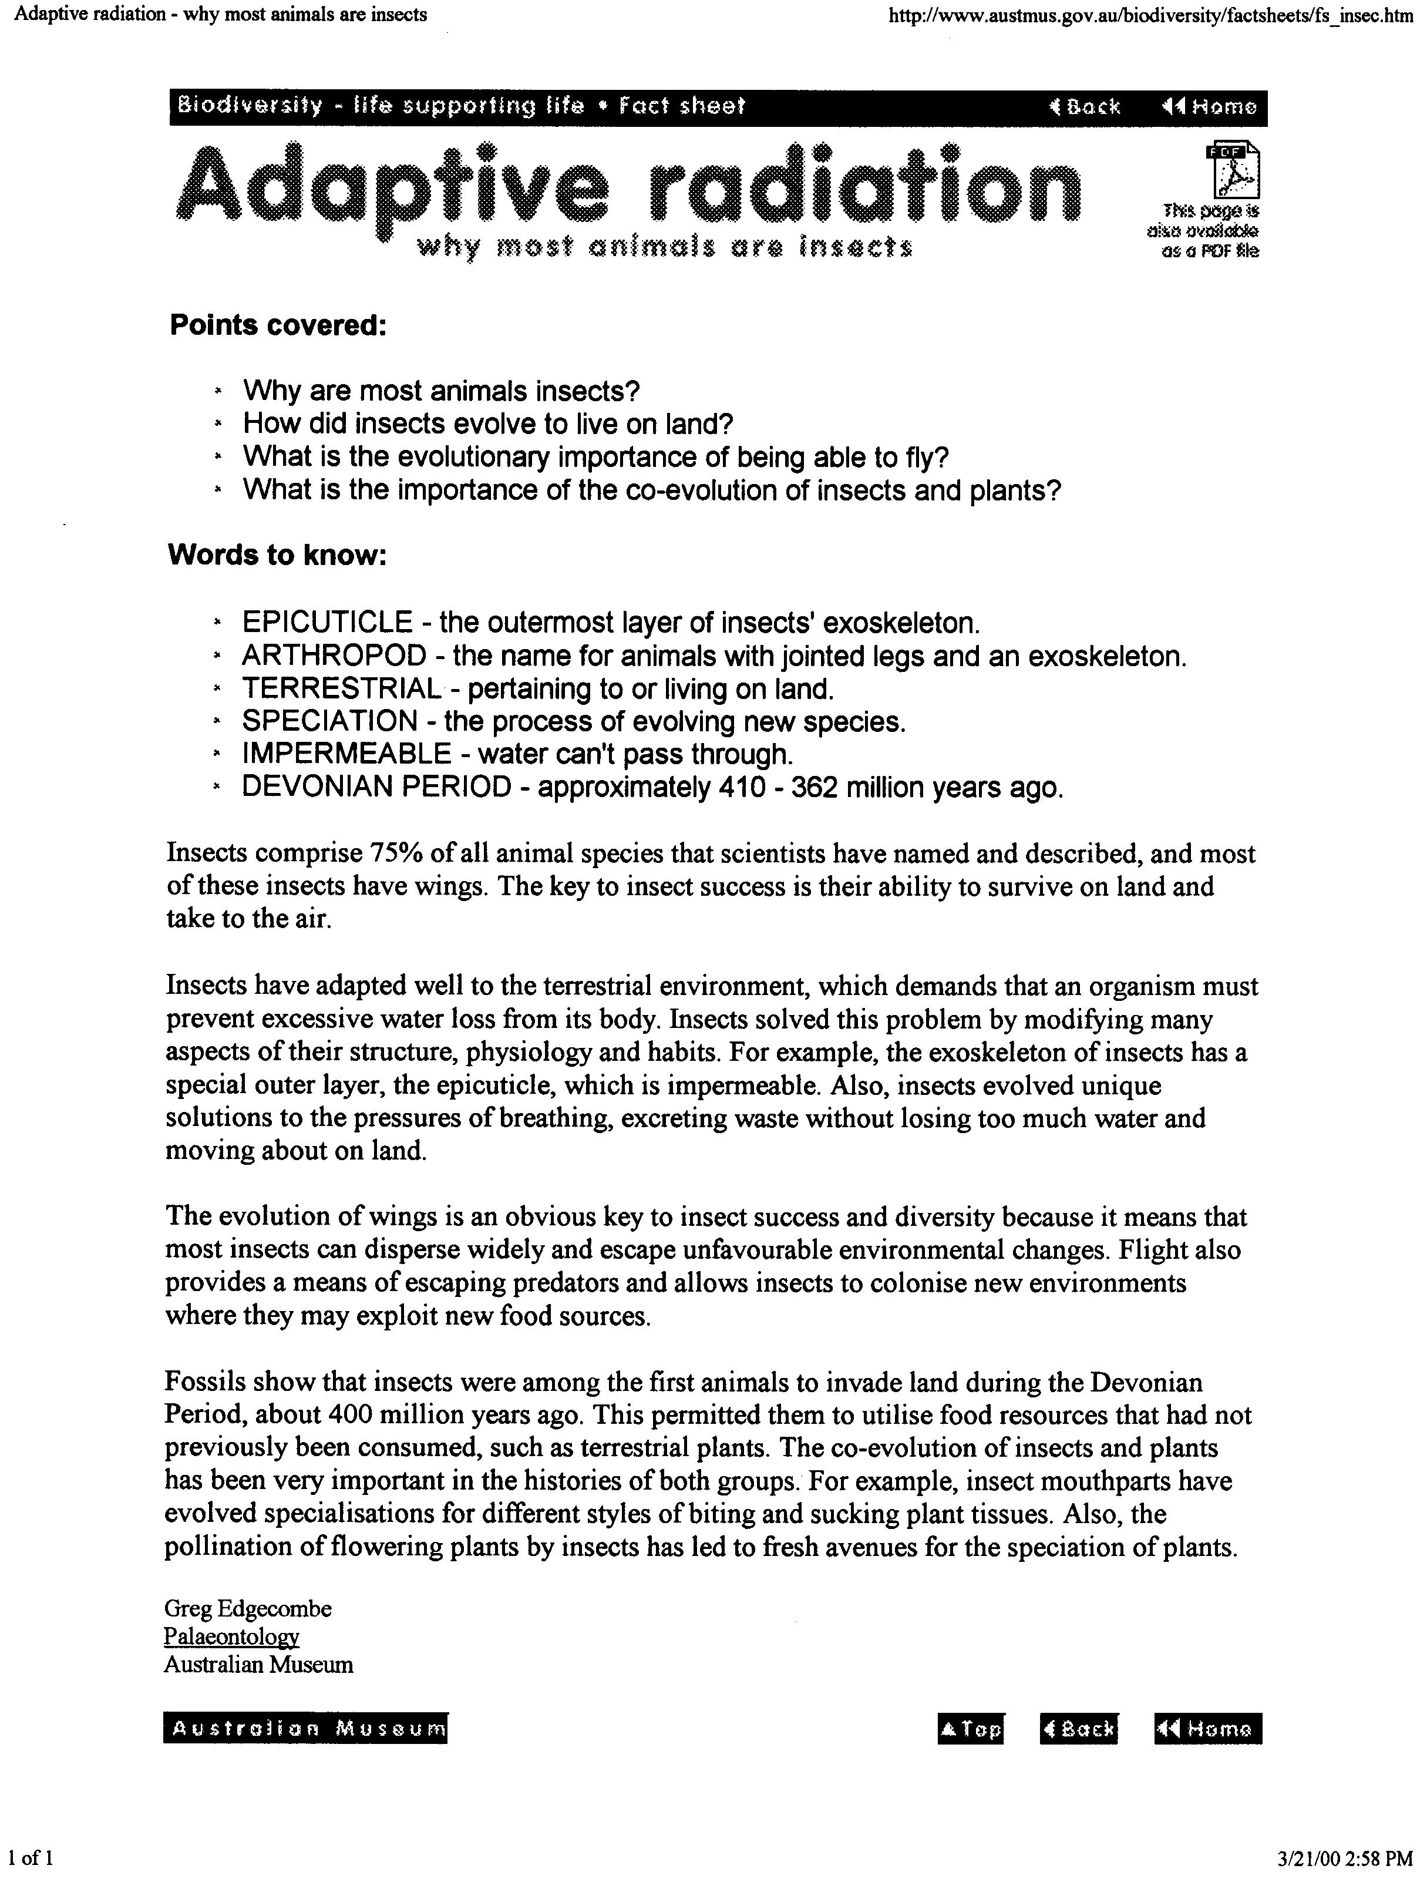

http://www.austmus.gov.au/biodiversity/factsheets/fs_insec.htm
[No longer connected, April 1, 2002]

Another indication of the position of insects in the world is the Discovery Magazine article in March of 1997 (see below) that explores the question why are there no insects in the ocean:

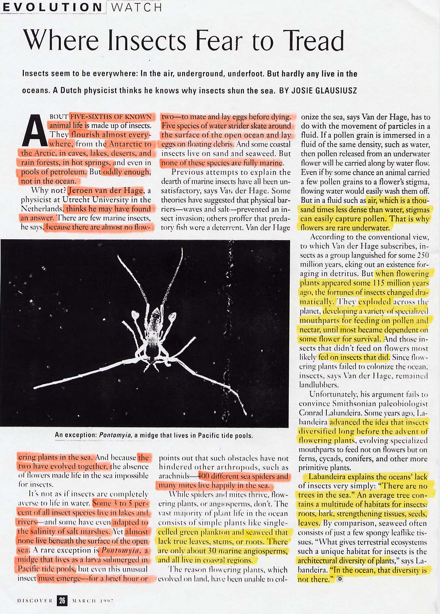

Discovery magazine, page 26, March 1997.

This article makes it clear that insects evolved with plants, either flowering plants or trees or both and this explains their diversity.

The fossil record shows that arthropods in the ocean predated insects. However, only the existing Onychophora invertebrates hint of a possible connection between annelids (worms) and arthropods.

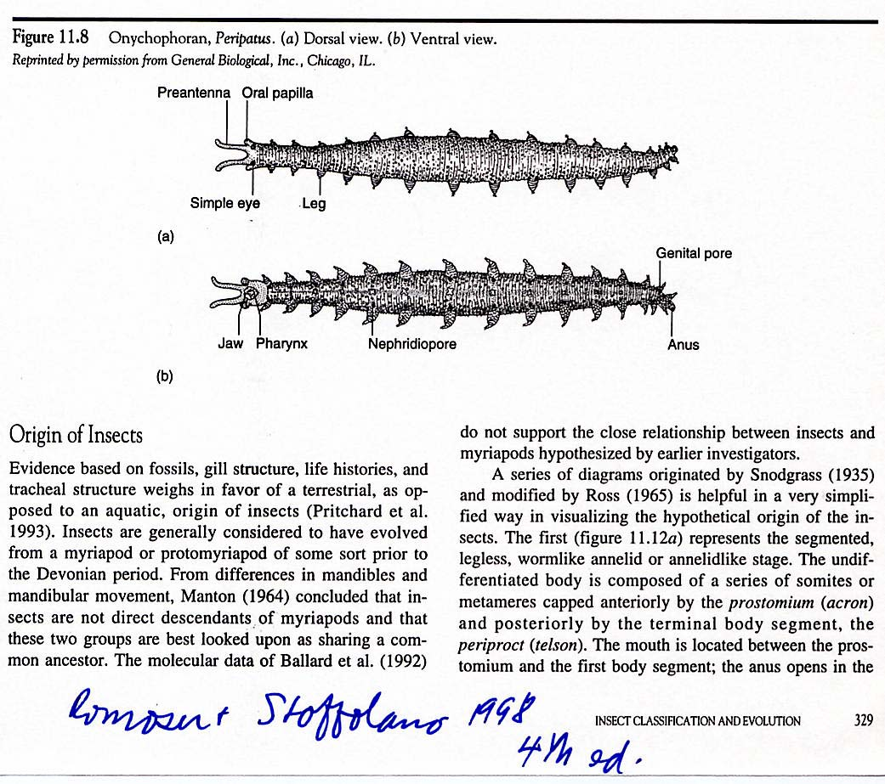
From Romoser and Stoffolano, 1998, p. 329.

Often associated with the antecedent form of invertebrates are the Onychophora or velvet worms (figure above). There are some 73 species of these organisms living exclusively in the tropical regions of the world. Physiologically they are intermediate between insects and annelids (true worms). They have the unjointed legs, and the excretory system, nervous system and body wall structure like that of worms. But they also have a chitinous cuticle like arthropods, plus a hemocoel, jaw, salivary glands, an open circulatory system, a tracheal respiratory system and claws at the tips of the legs just exactly like arthropods. Every phylogenetic scheme shows annelids then Onychophora then arthropods.

The word arthropod literally means jointed appendage. The major groups of arthropods are Chelicerata, which include the horseshoe "crab," Limulus polyphemus, water scorpions, scorpions, spiders, ticks and mites, and sea spiders; the Mandibulata, which includes crustaceans, Myriapoda, which includes centipedes, millipedes and Hexapoda.

A phylogenetic tree shows the relationship between crustacea, Onchophora and insects (see below).

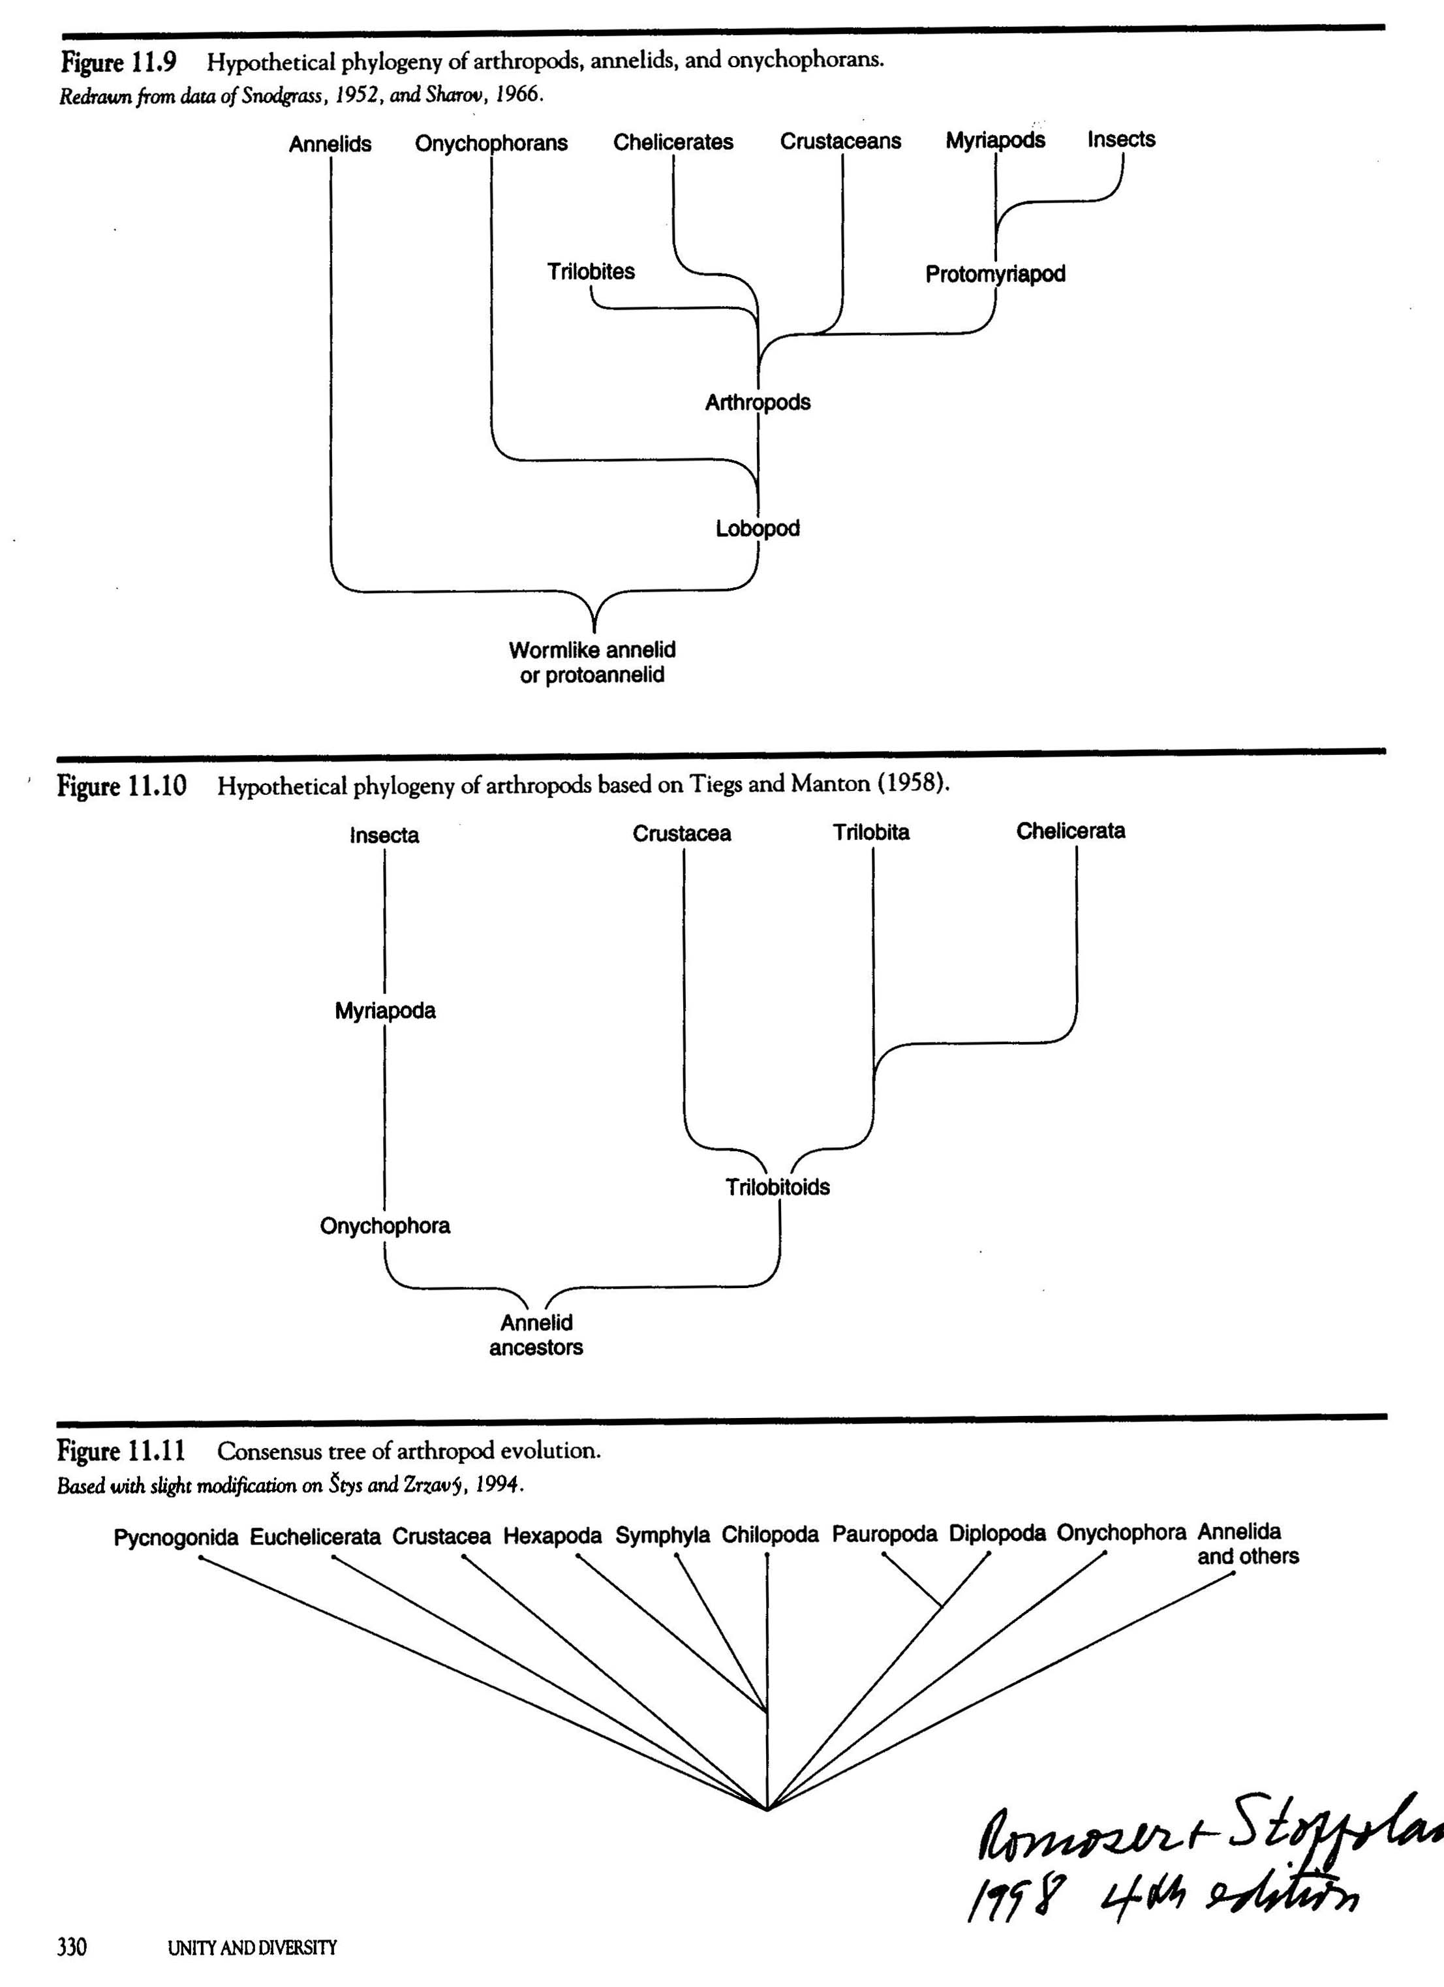
Page 330 from Romoser and Stoffolano, 1998.
Phylogeny of arthropods and annelids.

Notice all schemes put Onychophora near the division into Annelids and Arthropods. This is because of the unique properties of Onychophora that contain both arthropod-like traits and worm-like traits.

Two versions of the fossil record compare the first appearance of insects:

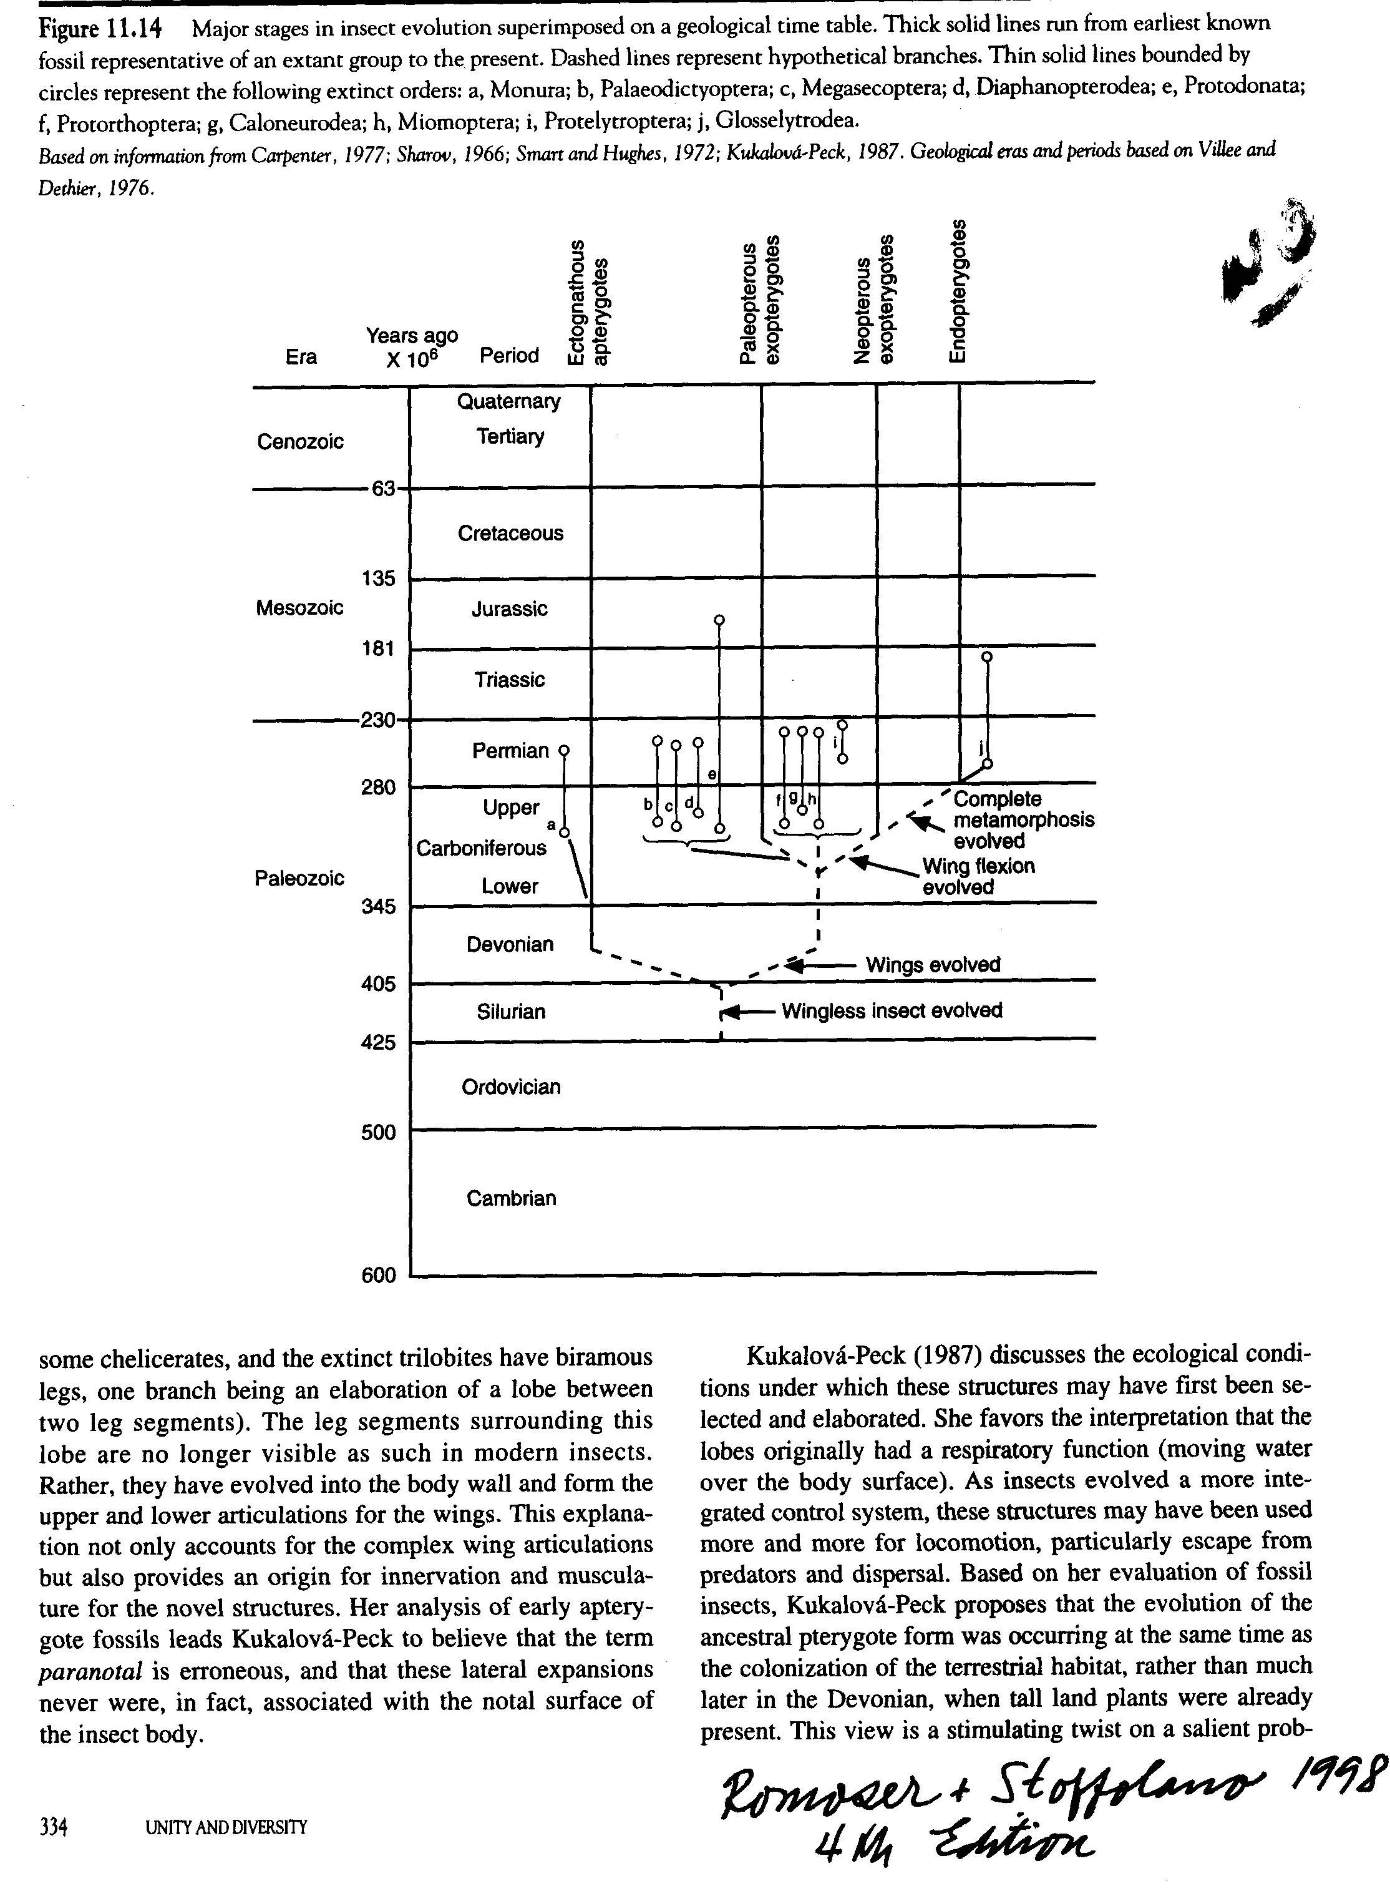
Page 334 from Romoser and Stoffolano, 1998.
Insects originated in the Silurian just before Devonian.

Insects are thought to have evolved just before the Devonian, the Age of Fish. Winged forms appear in the Devonian deposits, and wing folding and then pupal stages appeared later, but the insects as a group diversified first starting in the Devonian.

Viewed in a slightly different way, this diversion of insects was shown in the figure below from the textbook Entomology, by Cedric Gillott (1995, 2nd ed.):

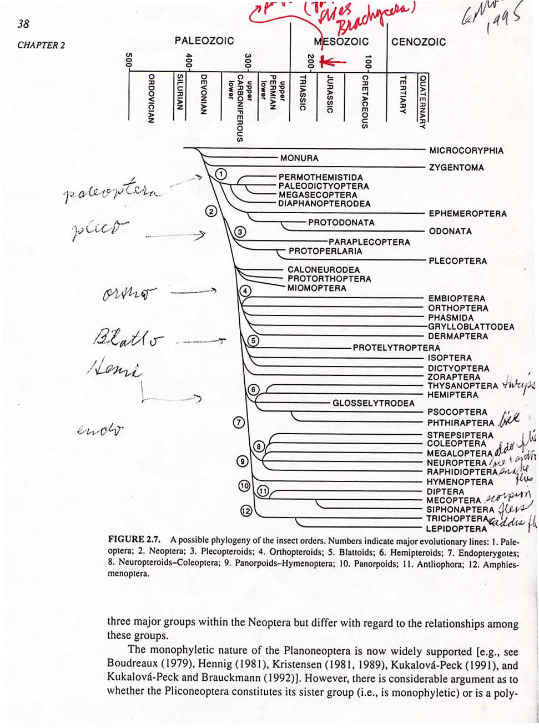
Page 38 from Gillott, 1995.

Note from the graphic above, the earliest insects evolved during the Devonian, but the advanced Orders proliferated later. The appearance and diversification of beetles, Coleoptera, the larges of the insect Orders is said to be connected with the evolution of flowering plants.

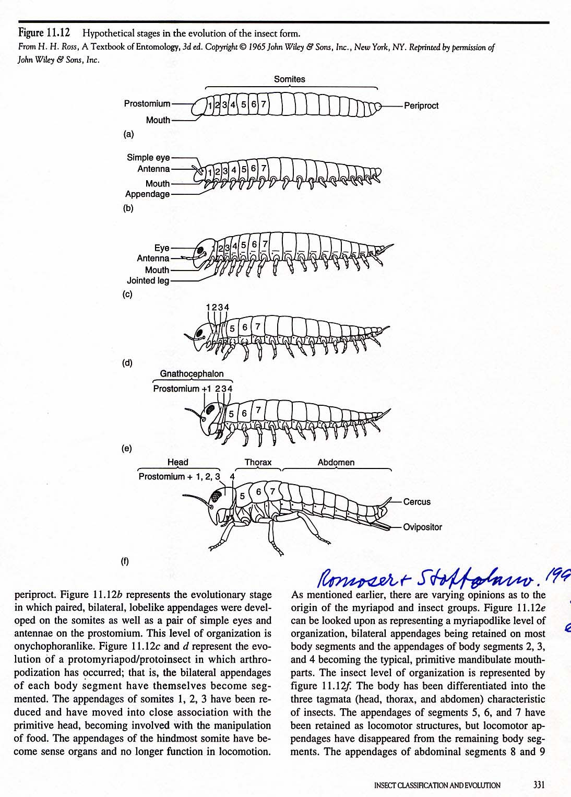
Page 331 from Romoser and Stoffolano, 1998.

The evolution of insects from a segmented worm hypothetical ancestor is shown in figure 11.12, page 331 from Romoser and Stoffolano (1998). In fact all advanced and primitive insects are segmented and the segments all retain their individual identifications with segmental features such as paired tracheal systems and paired nervous systems.

Originally the Hexapoda group included Collembola, Protura, Diplura and Thysanura mainly because they all had six legs; however, the first three of these hexapods are now thought to reside in a special category due to mouthparts and other characteristics that separate them from the Insecta. Thus insect are hexapods, but not all hexapods are insects.

Given below is an early version of the Appendix used in the Nation book:

Appendix to Insect Physiology and Biochemistry
James L. Nation (2002) “Insect Physiology and Biochemistry,” CRC Press, Boca Raton, FL.

Introduction
The purpose of this short section is to provide some background information about insects and their near relatives for those who may not be trained as invertebrate biologists or entomologists. I offer an apology in advance to those who may be a specialist on one or more groups of arthropods.

[It is not my intent in this section to make insects (or arthropods) seem simple morphologically, physiologically, or from an evolutionary point of view. My intent in this book, in fact, is just the opposite, to try to demonstrate the extraordinary complexity in physiology and biochemistry of this very successful group of animals. Accounts of their structure, physiology, behavior, and evolution fill volumes.]

The Arthropoda.
The phylum Arthropoda is divided by some authorities into five subphyla, while other authorities merely consider the different groups as classes of the Arthropoda. The subphyla and the classes they contain are the following:

1. Subphylum Trilobita – This subphylum (or Class) is an extinct group of marine arthropods that flourished in the Cambrian period some 500 million years ago. They are very common in the fossil record, were probably quite diverse, and if a modern systematists could have been present to study them when they lived, they would probably be divided into a number of classes.
2. Subphylum Chelicerata. The Chelicerata are commonly divided into four classes. The class Eurypterida, an extinct group called giant water scorpions, is known from fossils of the Paleozoic era. Some were as large as 2.5 meters, and were probably predators, perhaps on evolving fish. The class Pycnogonida contains the relatively rare and exotic sea spiders, marine arthropods found in the oceans and especially in shallow water near the North and South poles. The class Merostomata, nearly all of whom are extinct, includes the living group called horseshoe crabs. They are not true crabs but are the living relics of an ancient line of Chelicerata having changed little over 350 million years. Horseshoe crabs are marine bottom feeders living in shallow water along coasts of North and South America, China, Japan, and the East Indies. Limulus polyphemus, common in North American, has been important in physiological studies, particularly in studies of the compound eyes. The class Arachnida includes about 60,000 species, most of whom are carnivores. The class includes spiders, ticks, mites, scorpions, whipscorpions, daddy longlegs, and a few less common relatives.
Members of the Chelicerata typically have the body divided into two regions, a cephalothorax and an abdomen. They do not have antennae. The name for the group comes from the structure of the first pair of mouthparts, called the chelicerae, which may be pincer-like or fang-like, but not mandibulate. The second pair of mouth appendages are the pedipalps, which serve in a variety of functions in different groups of the Chelicerata, including food manipulation, locomotion, defense, and copulation.
The arachnids are the most diverse of the Chelicerata today, and members exhibit many morphological and physiological adaptations for life in varying terrestrial habitats. The body tends to be divided into a cephalothorax and an abdomen, although the latter is not evident in ticks and daddy longlegs. Arachnids do not have compound eyes nor antennae, but some have simple eyes on the cephalothorax. They typically have six pairs of jointed appendages. The first pair of appendages in spiders is the chelicerae, fang-like structures used to inject poison into the prey. The second pair, the pedipalps, is used by some spiders to manupulate and chew food. In some, the pedipalps are gustatory sensory organs, and in others they serve in courtship display and in sperm transfer. The remaining four pairs of appendages are used for walking. Some arachnids use tracheal tubes in gas exchange, others use book lungs, and some have both book lungs and tracheal tubes. Book lungs consist of a series of thin plates (like pages in a book, hence the name) paired ventrally at as many as four sites in some arachnids. The plates contain blood vessels and gas exchange occurs as blood flows through the plates. Air reaches the book lungs through slits in the outer body wall.
3. Subphylum Crustacea – Crabs, barnacles, shrimps, brine shrimps, crayfish, lobsters, fairy shrimps, water fleas, sand hoppers, and sow (pill) bugs are crustaceans. Crustaceans are a diverse group, and body morphology is highly variable, but most share the characteristics of having two pairs of antennae on the head and mandibulate mouthparts. The mandibles may be adapted for biting and chewing, or piercing and sucking. Most crustaceans also have a second pair of mouthparts called the maxillae that are used for holding and manipulating food. Additional appendages on the body are specialized for walking, swimming, sperm transfer, carrying eggs and young, or serve as sensory structures. Nearly all crustaceans live in aquatic habitats. Some live in marine environments and others in fresh water. The aquatic ones generally have gills for gas exchange and two large antennal glands that open at the base of each antenna and serve as excretory organs. Typically, adult crustaceans have compound eyes. Sow bugs are terrestrial, and have a tracheal system for respiration.
4. Subphylum Uniramia – This largest group of all living animals contains five classes, the Chilopoda (centipedes), Diplopoda (millipedes), Pauropoda (0.5-2 mm arthropods living in leaf litter and soil and resembling centipedes, although not necessarily closely related to them), Symphyla (a small group of small arthropods with mouthparts that resemble those of insects in the view of some, but not all, authorities), and the largest group of all other animals put together, the Insecta. Centipedes, millipedes, pauropodans, and symphylans share many characteristics with each other, including a long trunk with many legs, a five- or six-segmented head, and living in leaf litter, loose soil, rotting wood, and similar moist habitats. Some authorities recommend placing them together in the class Myriapoda, or even raising the group to a subphylum level.
In spite of their differences, arthropods share a number of characteristic features, including a chitinous exoskeleton that must be molted periodically as the animal grows, jointed legs, a well developed ventral nervous system, and an open circulatory system with a dorsal vessel or heart. The body of arthropods contains a hemocoel through which the blood flows freely once it leaves the dorsal vessel. The hemocoel is a cavity derived from the embryonic blastocoel and is not a true coelom, which is defined as a cavity lined by mesoderm. Various arthropods have gills (some aquatic ones), a tracheal system, book lungs, or book lungs and a tracheal system for gas exchange. Some arthropods have a blood pigment that aids in transport of oxygen to the tissues.

The Class Insecta
There are more than 750,000 described species of insects, with new ones being described on a continuing basis. Some authorities, such as E. O. Wilson of Harvard University, suggest that there are millions yet undescribed. Most authorities agree that insects are the most numerous animals, and most diverse in number of species and individuals on earth. The class Insecta is divided by authorities into a variable number of orders. Arnett (2000) lists 31 orders. The largest order, the Coleoptera (beetles and weevils), contains more than 300,000 described species. Those interested in more systematic and taxonomic details may consult one of the several general entomology textbooks listed at the end of this chapter.

Adult insects, and some immature ones, typically have six segmented legs, with one pair attached to each of the three thoracic segments. Some larval insects, such as Hymenoptera larvae and dipterous larvae, are legless. Other larval insects, such as caterpillars (Lepidoptera), have fleshy prolegs that are not jointed and that arise from various segments of the larval body. All insects molt from time to time as they grow to fill the old cuticular exoskeleton; they secrete a new exoskeleton beneath the old one before the old is shed, and then ecdysis of the old cuticle occurs.

Many orders of insects (described as Holometabola by some authorities and in this book) undergo complete metamorphosis, with egg, larva, pupa, and adult forms. Others have a gradual metamorphosis (the Hemimetabola) in which the immature, sometimes called a nymph but increasingly described as a larva by many authorities, looks much like the adult without wings (or with the beginning growth of wings in the later instars). There is no pupal stage in those with gradual metamorphosis, and the last instar molts into the adult. The Apterygota (the orders Protura, Collembola, Diplura, and Thysanura) are wingless both as larvae and as adults, and are considered to lack a metamorphosis, gradually changing into the mature adult with little or no obvious external change except size.

The term “instar” is sanctioned by the Entomological Society of America as a term to describe the immature individual (larva or nymph) between molts (1st instar, 2nd instar, etc.), and it also is used to describe the duration of time between molts. One should not say or write “2nd larval instar,” because it is redundant.

The body of insects is divided into segments, and there typically is a clearly defined head, thorax, and abdomen. The head in arthropods has evolved from the fusion of a number of segments, from three to seven depending upon different authorities, but it superficially appears to be all of one piece in most insects. Each of the primitive segments probably bore appendages, and these have evolved into the antennae and mouthparts. A pair of antennae occurs on the head of adult insects and some immature ones. The Protura lack antennae. The antennae have evolved into a wide variety of shapes in different groups. They bear a variety of sensory structures, many of which are olfactory. Authorities generally agree that the primitive mouthparts were of the mandibulate type. Other types of mouthparts, such as piercing and sucking, are derived from mandibulate components. The mandibulate type consists of paired ventrolateral mandibles and maxillae, the (ventral) labium, the (dorsal) labrum, and the hypopharynx. The labium and labrum extend beyond the true mouth and form a preoral cavity. The hypopharynx is part of the ventral surface of the head capsule and it extends into the preoral cavity between the labium and labrum. The salivary gland duct empties into the preoral space between the hypopharynx and labium. The maxillae each bear nonsegmented lobes called the galea and lacinia, and a segmented appendage, the maxillary palpus. The labium is derived from the fusion of two primitive segments, and it also bears several nonsegmented lobes and a pair of segmented labial palps. The palps and various lobes of the mouthparts bear tactile and gustatory receptors.

Part of the success of insects has been in the plasticity of their mouthparts and their evolution to support diverse food habits. Chewing mouthparts, often modified for specific trophic functions, are present in many orders of insects. Piercing and sucking mouthparts have evolved in the Hemiptera, adult Siphonaptera, and some Diptera, and sucking mouthparts occur in some Diptera, Hymenoptera, and Lepidoptera. The mouthparts may be reduced or vestigial in nonfeeding adults, such as some Lepidoptera, and in some endoparasitic insects.

The thorax is divided longitudinally into three segments, the prothorax, the mesothorax, and the metathorax. In a schematic form, each of the thoracic segments is like a box with a slightly rounded top, the tergum, that laps over considerably on the sides, two side plates (the paired pleura, singular pleuron), and a ventral plate, the sternum. Each thoracic segment bears a pair of segmented legs attached between the sternal and pleural plates. The mesothoracic and metathoracic segments of many adult insects bear paired wings attached by small wing sclerites (small pieces of cuticle that act like hinges) at the interface between the tergal and pleural plates. Some adult insects are wingless, and this is considered to be a secondarily evolved condition from winged ancestors. Wings probably evolved only once in some early ancestor of winged insects.

Several factors (complex behavior, external and internal morphology, physiology and biochemistry, size, food habits, flight, exoskeleton, and metamorphosis) have contributed to the success of insects in becoming the most diverse and largest group of animals. In fact, just about anything one describes about insects must have contributed to their success. Since this is a book about the physiology and biochemistry of insects, those features are the ones that are stressed, but many morphological, behavioral, and genetic factors also could be cited.

They have a well-developed nervous system enabling complex individual behavior, and social behavior in ants, termites, some Hymenoptera, and to a limited extent in some other groups. Virtually all insects have an extraordinary array of sensory receptors that enable them to gather information about the internal and external environment. An exoskeleton provides protection from the external environment, controls water loss from a body that has a very high surface to volume ratio, and provides for skeletal muscle attachments.

The tracheal system, a system of air-filled tubes, arborizes like the human capillary system to virtually every cell in the body, and allows air to move through an air path to within a few micrometers of mitochondria. Consequently, insects nearly always respire aerobically, even during periods of prolonged flight. Thus, they get the maximum energy release from the breakdown of carbohydrates, and some groups can metabolize fatty acids for even greater amounts of energy during flight.

Flight has certainly been a major factor in the success of insects, allowing rapid and wide dispersal, escape from enemies, and searching for mates, food, and habitats. The use of semiochemicals in communication, and location of mates, food plants, and prey is well developed and seems to have reached an apex in the moths, which fly at night and depend upon olfaction to find food and mates. Sex pheromones play an important role in sexual isolation today, and probably has done so over millions of years.

A great radiation of insects occurred during the evolution of flowering plants about 140 million years ago, and insects feed upon nearly every type of plant. Their food habits and alimentary canal structure evolved together, so that diversity in food is reflected in great diversity in gut structure. Small size has in itself been a major factor in success. They live in many diverse microhabitats, and a small body requires relatively less food to grow and to sustain life.

Insects have a very complex endocrine system involving steroid hormones, neurosecretions, neuromodulators, biogenic amines, second messengers, and possibly a unique hormone, the juvenile hormone. Hormones and neurosecretions regulate growth, metabolism, behavior, molting, metamorphosis, excretion, circulation, reproduction, and probably many processes yet to be discovered. Genetic diversity has enabled them to adapt to changing environmental and food conditions over several hundred millions of years.

The Evolution of Insects
At one time or another, authorities have proposed a single evolutionary line for the insects (monophyletic), diphyletic origins, and polyphyletic origins (Gillott 1995). Based on the fossil record, the first insects evolved as wingless forms about 400 million years ago during the Devonian period of the Paleozoic era. The early fossil insects looked much like some thysanurans do today. Great radiation in the evolution of insects occurred in the Carboniferous period (360 million ears ago, Paleozoic era) when the earth was dominated by large primitive vascular plants and later in this period by ferns and gymnosperms. A second great expansion of insects occurred during the Cretaceous period about 140 million years ago in the Mesozoic period when flowering plants were expanding and gymnosperms were declining.

Insects are generally believed to have evolved from a line of ancient annelid-like ancestors. Some biologists believe that insects evolved from an ancient onychophoran-like ancestor. Onychophorans evolved as marine invertebrates more than 500 million years ago and were numerous; fossils of these soft-bodied animals marine animals are preserved in Cambrian deposits. Today the onychophorans comprise a group of about 65 species of living velvet worms in the genus Peripatus. These caterpillar-like worms mostly live in moist tropical habitats, and have some characteristics of both annelid worms and arthropods. Onychophorans have a segmented body, a pair of antennae, and from 14-43 pairs of short, unsegmented legs. They are similar to annelid worms in having a thin, permeable, flexible cuticle, a pair of nephridia (excretory organs) in each segment, and an annelid-like nervous system. Like insects, they have claws, an open circulatory system, a tracheal system, a hemocoel, insect-like mandibles, and salivary glands. Some authorities in the past have considered onychophorans as a class in the Arthropoda, but they are often placed into the separate phylum Onychophora.

Clearly, the evolution of wings in insects made a major contribution to their success. When and how wings evolved is not clear, and authorities have proposed a number of theories. Evolution of wings is briefly discussed in Chapter 10, but for more comprehensive discussion of the various theories, the reader may consult Gillott (1995).

Another major evolutionary step was the evolution of a pupal stage. This, too, has led to numerous theories (Gillott 1995). One advantage of the pupal stage is that it allows the larval and adult forms to have very different food habits and to occupy different habitats, thus reducing intraspecific competition. It has enabled some temperate climate insects to survive long, cold winters in the pupal stage.

Cited and Selected References
Arnett, R.H., Jr. 2000. American Insects, A Handbook of the Insects of America North of Mexico, 2nd edition, CRC Press, Boca Raton, FL.

Chapman, R.F. 1998. The Insects, Structure and Function, 4th edition, Cambridge University Press, New York.

Evans, H.E. 1984. Insect Biology, A Textbook of Entomology, Addison-Wesley, Reading, MA.

Gillott, C. 1995. Entomology, 2nd edition, Plenum Press, New York.

Gould, J.L, and W.T. Keeton. 1996. Biological Science, 6th edition, W.W. Norton & Co., New York. Pp. 540, 680-691.

Romoser, W.S., and J. G. Stoffolano, Jr. 1998. The Science of Entomology, 4th edition, McGraw-Hill, Boston.

Solomon, E.P., L.R. Berg, D.M. Martin, and C.Villee. 1996. Biology. 4th edition, Saunders College Publishing, Orlando, FL, pp. 636-649.

Table 1.
A listing of insect orders and type of metamorphosis according to Arnett.
Ametabola Hemimetabola Holometabola

Collembola
Protura
Entotrophi
Microcoryphia
Thysanura
Mallophaga
Anoplura

Ephemeroptera
Odonata
Plecoptera

Thysanoptera
Grylloblattodea Dictyoptera
Zoraptera
Orthroptera
Homoptera
Hemiptera
Phasmitodea
Psocoptera
Embioptera

Trichoptera
Hymenoptera
Neuroptera
Coleoptera
Diptera
Lepidoptera
Mecoptera
Siphonaptera

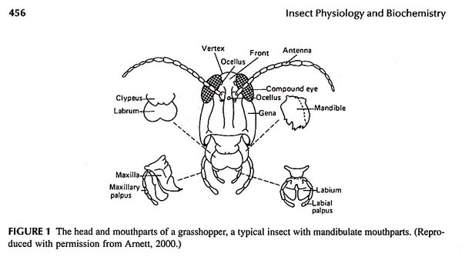
Figure One from Appendix of Nation (2002) textbook.

]
We have a special reason for concentrating on the Thysanura, the most primative insect group largely because they are the only insects in which the prothoracic gland persists into the "adult" stage. Adult is in parentheses because these primitive insects continue to molt after they begin to reproduce. No other insect group in the so-called advanced orders does this. And only the Ephemeroptera, the Mayflies, molt twice as a winged form. These two features of primitive insects set them apart from all the other insects.

Wings and pupae.
Two features that characterize insects exclusively amongst arthropods are wings and pupae. Friday you will begin the study of the hormonal control of insect development, and to anticipate that, today you should consider the three main types of insects, ametabola, hemimetabola and holometabola. I realize that James Nation recognized two forms of hemimetabola, but I want to ask you to combine these and consider only three categories.

The theory of the pupal stage has been debated by the leading insect physiologists since the field began. Why was a pupal stage developed? Some point to the inescapable presence of wings and pupae together. However, there is one obvious fact wrong with this association, the hemimetabolous insects with wings do not have a pupal stage. But there is one other obvious difference between hemimetabolous insects and holometabolous insects. The hemimetabolites develop wings externally during development and wing pads are obvious features on the stages immediately prior to adult stages. These are called exopterygota. The holometabolites all develop wings internally during the pupal stage and these are all called endopterygota.

Some events from the fossil record.

Jurassic 170 mya (dinosaurs)
Triassic 220 mya (ectoparasitic insects on mammals)
Permian 250 mya (first flowers, endopterygotes diverge)
Carboniferous 310 mya (exopterygote insect orders present)
Devonian 370 mya (age of fish, first land Hexapods, Collembola)
Cambrian 515 mya (marine arthropods abound)

Events in evolution related to insects as arthropods:

Cambrian arthropods Xiphosurans and Brachiopods survive.
Scorpions and millipedes became terrestrial.
Devonian (Age of Fish) first land insect, Collembola, springtail.
Carboniferous Great Hexapod diversity established diversion to most modern insect Orders.
Permian Extinction event (first flowering plants -- follow Coleoptera back).
Mesozoic (Permian) first flowering plants and exploitation by insects.

.

Separation of pterygota into paleoptera and Neoptera on the basis of the ability to fold the wings. Hexapoda (from Borror, et al, 1992, page 150) Entognatha separated from Insecta all of which are called Hexapoda. Hexapoda and Insecta mean different things, know the distinction. 75% of the described animal species are insects, there are about 751,000 described insects (versus 281,000 other animals and 284,000 plants). Of these the 300,000 described beetles (Coleoptera) are by far the largest group. Beetles are thought to be so prevalent because they diversified along with and were able to exploit the flowering plants that started developing from the Permian time. Only a few insects are associated with the ocean, the vast majority of insects never returned to the sea after colonizing the land.

The numbers of species in the largest orders of insects, according to Gillott are:
Coleoptera 300,000
Lepidoptera 200,000
Hymenoptera 130,000
Diptera 110,000

Since these numbers add to 740,000, it can be seen that they comprise the bulk of the Class Insecta. Remember, these numbers are gross estimates only. Indeed, the actual number of insect species is thought to be at least double this figure or greater.

The common Orders of insects.
Hemiptera (the true bugs, including Rhodnius, mentioned before, and aphids, or plant lice that have an unusual reproduction cycle)
Siphonaptera (=Psocoptera, booklice, lost wings through evolution)
Phthiraptera (lice, an Order that has lost wings through evolution.
Endopterygota, Holometabola
Hymenoptera (ants, wasps and bees)
Diptera, flies (house flies, blow flies, mosquitoes, midges)
Siphonaptera (fleas, another Order that has lost wings through evolution)
Lepidoptera (moths and butterflies).

Separation of Pterygota into Paleoptera and Neoptera on the basis of the ability to fold the wings. The Entognatha are now distinguished from Insecta on the basis of mouthparts and embryological development. Both groups together are called Hexapoda (see Borror, et al, 1992, page 150).

Seventy-five percent of the described animal species are insects, there are about 751,000 described insects (versus 281,000 other animals and 284,000 plants). Of these the 300,000 described beetles (Coleoptera) are by far the largest group. Beetles are thought to be so prevalent because they diversified along with and were able to exploit the flowering plants that started developing from the Permian time. Only a few insects are associated with the ocean, the vast majority of insects never returned to the sea after colonizing the land.

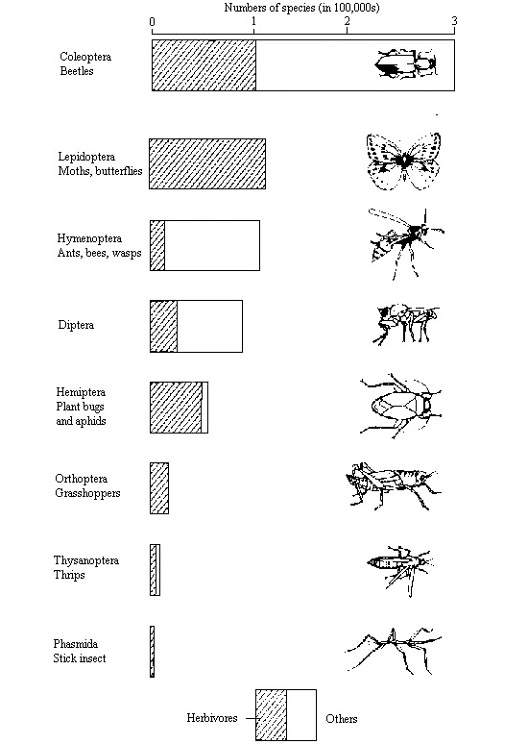

After: Romoser (1998) Insect numbers and diet,
p. 298, Fig. 10.7

