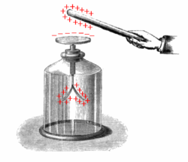**2012 June 28 Summer Lecture on E&M for HS Teachers** Allen Mills

gold leaf electroscope

**A. Charles-Augustin de Coulomb: Law for force between discrete charges, 1785**

**“***It follows therefore from these three tests, that the repulsive force that the two balls - electrified with the same kind of electricity -- exert on each other, follows the inverse proportion of the square of the distance.***”**

where 

**B. 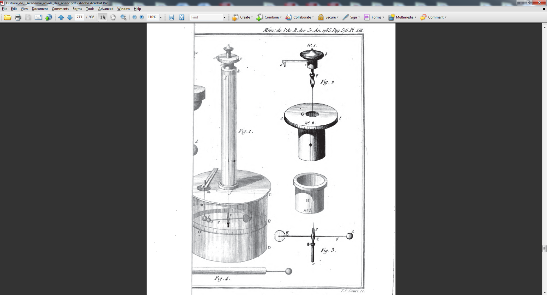Experimental facts**: *F* is (1) proportional to the product of the charges *qq’*, (2) inversely proportional to *R*2, with 2=2±3×10-16 (3) repulsive or attractive for like or unlike charges, (4) directed from one charge to the other.

(5) Charge is a scalar quantity, (6) there are only two kinds of charge, (7) all charges are sums of an elementary charge so that charge is exactly quantized, (8) charge is exactly conserved, (9) atoms are exactly neutral, (10) the forces between charges at rest are vector quantities and may be added etc., and (11) the elementary charges in the form of electrons and antielectrons or positrons are as far as we know perfectly pointlike, having a diameter of less than 10-18 m.

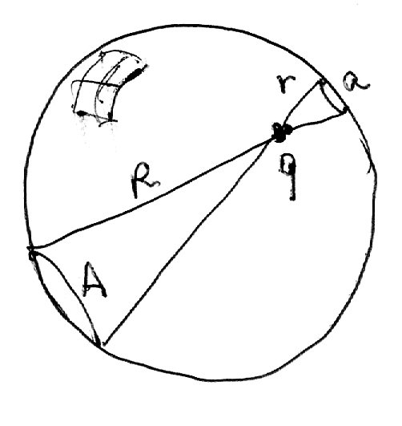The 1/r2 is required if the photon has no mass. You can make up mechanical models involving solid angle…. Is it geometry [A. Wyler, C.R. Acad. Sci. A269, 743 {1969), R. Gilmore, Phys. Rev. Lett. 28 462 (1972)] or what, because in the end science is based on experimental findings that are taken as facts with the weight of postulates or working assumptions until proven otherwise.

The fact that a spherical distribution attracts from the center is dictated by the power of 2 in the inverse square law.

**C. Ben Franklin’s theorem:** There is no force on a charge inside a uniform shell of charge.

**D. The electric field** is the force per unit charge. What does it mean? Nothing, … until you appreciate the experiments that show the electric field has an existence independent of charges that are its source. Then you find out that the electric field has energy associated with it, so it is not just made up or a convenience.

**E. The electrostatic potential** is the work done per unit charge moving about in an electric field or amongst other fixed charges.

**F. The energy of the electric field.**

**(1) Reality of the vector potential:** Faraday’s law of induction may be written

Assuming the static electric potential, the surface and its boundary are all constant, we conclude 

**(2) The four Maxwell equations** giving the interrelations between *D*, *E*, *B*, *H*, *Jf*, and *f*.

are; ; ;

**(3) The constitutive equations** for the case of linear, isotropic and homogeneous matter.

are; and ; , where is the current due to beams of charged particles.

**(4) Charge conservation is implied by Maxwell’s equations**.

Taking the divergence of the curl *H* equation implies the continuity equation,.

**(7) Maxwell’s equations in vacuum imply the existence of waves in the electric and magnetic fields traveling at the speed of light**.

We know that in vacuumand anywhere.

Take the curl of the curl Maxwell equations in vacuum to get and .

Now use the constitutive equations to get  (24-5) and  (24-6), where is one over the square of the speed of light in vacuum and we remember that the two fields are related by .

The solutions are of the form  (24-11) and so represent waves of arbitrary shape traveling at speed *c*.